

**SmartCoop: A Web Based Loan Management System with Descriptive Analytics for DOrSU-MultiPurpose Cooperative**

**Dave S. Malinab**

**John Llyod L. Bonga**

**Jerard Justine B. Gary**

**A BSIT Capstone Project Proposal presented to the Faculty of Computing, Data Sciences, Engineering, and Technology of the Davao Oriental State University in Partial Fulfillment of the Requirements for the Degree**

**BACHELOR OF SCIENCE IN INFORMATION TECHNOLOGY**

**JUNE 2023**



**TABLE OF CONTENTS**

|  |  |  |  |
| --- | --- | --- | --- |
| **TITLE PAGE** | | | |
|  | | |  |
| Title …………………...…………………………………………….…....…….......... | | | i |
| Approval Sheet……………………………………………………………………….  Table of Contents ……………………………………………………….…………... | | | ii  iii |
| List of Tables ……………………………………………………………….……...... | | | vi |
| List of Figures …………………………………………………………….………… | | | vii |
|  | | |  |
| **CHAPTER I INTRODUCTION** | | |  |
|  | 1.1 | Rationale of the Study ……….…………………………………… | 1 |
|  | 1.2 | Purpose and Project Description ……………….……………….. | 3 |
|  | 1.3 | Objectives of the Study ………………….……………………….. | 4 |
|  | 1.4 | Significance of the Study …………………….…………………… | 4 |
|  | 1.5 | Scope and Limitation ………………….………………………….. | 6 |
|  | 1.6 | Conceptual Framework ……………….………………………….. | 10 |
|  | 1.7 | Definition of Terms ………………….…………………………….. | 12 |
|  |  |  |  |
| **CHAPTER II REVIEW OF RELATED LITERATURE** | | |  |
|  | 2.1 | Technical Background………………………………...……………  2.1.1 XAMP………………………………………………...............  2.1.2 Visual Studio Code…………………………………………..  2.1.3 CSS……………………………………………………………  2.1.4 Bootstrap……………………………………………………...  2.1.5 Javascript……………………………………………………..  2.1.6 PHP……………………………………………………………  2.1.7 Laravel…………………………………………………...…… | 14  14  14  15  15  16  16  17 |
|  | 2.2 | Related Literature ………………………………………...……….. | 17 |
|  | 2.3 | Related Systems …………………………………..………………  2.3.1 Black Cat Loan Management System……….…………….  2.3.2 Loan Management System by Mortech………….………..  2.3.3 Loan Management System of Postbank of the Philippines…………………………………………………………..  2.3.4 Loan Management System for Ever First Loan Corporation………………………………………………………….  2.3.5 Financial Reporting System………………………………... | 21  21  21  22  22  22 |
|  | 2.4 | Synthesis …………………………………………………………… | 23 |
|  |  |  |  |
| **CHAPTER III MATERIALS AND METHODS** | | |  |
|  | 3.1 | System Methodology ……………………………………………… | 25 |
|  |  | 3.1.1 Planning Phase ………………………………….................  3.1.2 Analysis Phase……………………………………………….  3.1.3 Design Phase………………………………………………...  3.1.4 Development Phase…………………………………………  3.1.5 Testing Phase………………………………………………...  3.1.6 Implementation Phase………………………………………  3.1.7 Maintenance Phase………………………………………….  3.1.8 User’s Acceptance Survey…………………………………. | 26  26  26  26  27  27  27  27 |
|  | 3.2  3.3 | Mock-up Design ……………………………………………………  3.2.1 Admin View…………………………………………..............  3.2.2 Client View……………………………………………………  GANTT Chart………………………………………………………. | 28  28  39  43 |

**LITERATURE CITED** …………………………………………………………..……44

**APPENDICES**………………………………………………………………………… 51

Appendix A…………………………………………………………. 52

**LIST OF TABLES**

|  |  |  |
| --- | --- | --- |
| **TABLES** | **PAGE** | |
|  | |  |
| Table 3.1: Admin Login Interface ………………………………………………… | | 28 |
| Table 3.2: Admin Dashboard Interface ….……………………….……………… | | 30 |
| Table 3.3: Borrower’s Interface ………………...…….………………………….. | | 30 |
| Table 3.4: Loan’s Interface ……………...………..…….………………………... | | 31 |
| Table 3.5: Loan Parameters Interface …………….………..…………………… | | 32 |
| Table 3.6: Repayment’s Interface ….……….……………………………………  Table 3.7: Report’s Interface ….……………..……………………………………  Table 3.8: Access Configuration’s Interface ….……….……...…………………  Table 3.9: Users Log’s Interface ….……….……………………………………..  Table 3.10: Setting’s Interface ….………….…..…………………………………  Table 3.11: My Profile’s Interface ….………..……………………………………  Table 3.12: Client Sign in Interface ….……….……………………….…………  Table 3.13: Client Dashboard Interface ….…….….………….…………………  Table 3.14: Loan Application Interface ….……….………………………………  Table 3.15: Repayment’s Interface ….……….……………………………..…… | | 33  34  35  36  37  38  39  40  41  42 |

**LIST OF FIGURES**

|  |  |
| --- | --- |
| **FIGURES PAGE** | |
|  |  |
| Figure 1.1 Conceptual Framework…………………………………………….……. | 10 |
| Figure 3.1 Iterative Model………………………………………………….………… | 25 |
| Figure 3.2 Admin Login Interface ……………………………………….…..……… | 28 |
| Figure 3.3 Admin Dashboard Interface …………………………….………………. | 29 |
| Figure 3.4 Borrower’s Interface ………….……………………….………………… | 30 |
| Figure 3.5 Loan’s Interface.….………………………………….…….…................. | 31 |
| Figure 3.6 Loan Parameters Interface ………….…………….……………………. | 32 |
| Figure 3.7 Repayment’s Interface ……………………..…….……………………..  Figure 3.8 Report’s Interface ………..............................…….……………………  Figure 3.9 Access Configuration Interface ………...……….……………………...  Figure 3.10 User Log’s Interface ………...………………………………………….  Figure 3.11 Setting’s Interface ………...………………….…………………………  Figure 3.12 My Profile Interface ………...…………………………………………..  Figure 3.13 Client Sign In Interface ………...………….……………………………  Figure 3.14 Client Dashboard Interface ………...………………………………….  Figure 3.15 Loan Application Interface ………...…….……………………………..  Figure 3.16 My Application Interface ………...…………………………………….. | 33  34  35  36  37  38  39  40  41  42 |
|  |  |
|  |  |

**CHAPTER I**

**INTRODUCTION**

**1.1 Rationale of the Study**

Loans are a fundamental aspect of personal and commercial finance. According to a report by the Federal Reserve Bank of New York, outstanding household debt, which includes mortgage loans, auto loans, and credit card debt, reached $14.95 trillion in the second quarter of 2021 (Federal Reserve Bank of New York, 2021). Similarly, businesses also rely heavily on loans to finance their operations and growth. A study by the National Small Business Association found that 73% of small businesses used some form of financing, including loans, to fund their operations (National Small Business Association, 2020).

Lenders such as banks, credit unions, and online lenders provide loans to individuals and businesses. These loans come in different types, such as secured and unsecured loans, with varying interest rates and terms. Borrowers are required to pay back the original amount of the loan along with any additional interest or finance charges, making it important for borrowers to carefully consider their ability to repay the loan before borrowing.

Davao Oriental State University – Multipurpose Cooperative (DOrSU – MPC) provides financial services, including loans, to over 300 employees of Davao Oriental State University these types of loans are; Emergency, Educational, Gadget, Regular, Bonus, and PEI loan. Currently, they use manual loan processing system and they adopt electronic ones as well, but according to Peterson (2017), manual loan processing lacks consistency, audibility, and accuracy, which can lead to delays and lost opportunities for lenders. Furthermore, traditional manual loan processing is increasingly becoming outdated in today's digital world, as it is time-consuming and prone to errors, which can result in losses for financial institutions. This is why financial institutions have started adopting systems that offer flexibility, speed, and scalability to manage their loan processing more efficiently.

To address these challenges, DOrSU-MPC needs to implement an online loan management system. This would ensure data integrity, transparency, and scalability, while also providing faster disbursement of funds. An online system would allow for the efficient processing of loan applications and quick approval, eliminating the need for physical documentation. With the ongoing pandemic, the need for efficient online processing has become even more critical. By investing in technology, DOrSU-MPC can improve their loan management system, making it more efficient, and providing better financial services to their members.

Upgrading their loan management system would be beneficial for DOrSU-MPC as it would increase their efficiency and improve their overall performance. The new online system would reduce processing times, decrease the likelihood of errors, and provide a more transparent process for their members. It would also eliminate the need for manual documentation, making the process much simpler and more convenient. By investing in technology, DOrSU-MPC would ensure that they meet the evolving needs of their members and provide better financial services.

To improve their loan management efficiency and scalability, DOrSU-MPC can adopt a loan management system with descriptive analytics and a web portal for coop members, enabling real-time transparency and faster disbursement of funds. According to Walker (2019), such systems offer significant benefits for financial institutions, including improved data accuracy, faster processing times, and enhanced customer experience. By leveraging technology, DOrSU-MPC can streamline their loan processing, reduce errors, and enhance the member experience. This is particularly important during the pandemic, where efficient online processing is more critical than ever before. By investing in an online loan management system, DOrSU-MPC can provide better financial services, meet their members' evolving needs, and improve their overall performance.

**1.2 Purpose and Project Description**

The SmartCoop project aims to develop a web-based loan management system with descriptive analytics capabilities for the DOrSU-MPC. The system will streamline loan processing, management, and reporting, providing the cooperative with efficient and effective loan management capabilities. Its key features include online loan application processing, automated payment processing and collection, member access to loan information and payment capabilities, advanced analytics and data visualization tools, and comprehensive loan portfolio management and reporting. The system will enhance the cooperative's financial performance, reduce risks, and provide better services to its members. The SmartCoop project will significantly improve the DOrSU-MPC's loan management process, ensuring transparency and accuracy while increasing efficiency and scalability.

**1.3 Objectives of the Study**

General Objective: To develop a loan management system for DOrSU-MPC that is efficient and reliable in managing loan transactions.

Specific Objectives:

1. Develop a Loan Management System with Descriptive Analytics for DOrSU-MPC which capable of the following:

* A web admin panel for the administrator that includes: dashboard**,** borrowers, loans**,** loan parameters, repayments**,** reports, access configuration**,** user logs**,** settings, and my profile.
* A web user panel dashboard for the borrower that includes:general information**,** andloan request.
* Allow the management to view borrowers’ accounts, loan types, and rates.
* To implement descriptive analytics to generate loan application trends.

1. Evaluate the performance of the software using ISO/IEC 25010:2011 criteria for quality software.
2. To create an implementation plan for the deployment of the Loan Management System with Descriptive Analytics for DOrSU-MPC.

**1.4 Significance of the Study**

The loan management system with descriptive analytics aimed to guide the borrowers in DOrSU. It is significant, particularly to the following:

* **The Credit Committee.** The credit committee will benefit from this study since it will make it easier for them to determine whether the loan application gets approved or refused.
* **Member of Coop.** This study will benefit coop members since they will be able to apply for a loan online, check the status of it, and receive real-time updates.
* **The Organization.**This study will be beneficial to the coop. because it can provide an easy access system, reliable and faster business transactions.
* **The Manager.**This will benefit the manager in handling tasks simultaneously during the process with accurate output and can give comfort to the management.
* **The Assistant.** This study will help the assistant to lessen their paper works by eliminating the need for manual compilation, organizing the record, and monitoring the borrower’s loan account.
* **The Bookkeeper.** This study will be beneficial to the bookkeeper in a way that it will be no need to compile manual records and easy to track the borrower details.
* **The Researcher.** This study will help the researchers develop their system and provide more concepts regarding making documentation.
* **The Future Researcher.**This study will help future researchers who want to develop or conduct studies about loan management systems. It will provide references for further study that will benefit any researcher who wishes to enhance this existing system.

**1.5 Scope and Limitation**

This project is focuses in providing a web-based loan management system with descriptive analytics for DOrSU - Multipurpose Cooperative. The study will draw on recent studies and research to explore cooperatives' loaning capacities, notably the benefits they provide to members during times of emergency, such as the current pandemic. The application's implementation will be confined to the following areas:

* The study focuses on improving loan management efficiency and scalability
* Web admin panel dashboard has an overview of the system, including key metrics such as the number of active clients, the total disbursement, payment receive, total debit and the collection of distribution.
* For web admin panel borrower section, we will include a list of all borrowers, including their ID number, contact information, loan status, lists of pending borrowers, and add button for adding borrowers, along with contact details, the admin can upload necessary documents when adding a new borrower as part of the loan requirements.
* For web admin panel loan section, we include the loan portfolio report where you can see the ID number of the borrower, borrower name, capital, current balance, date of disbursement, loan window, and status whether its pending for approval, past maturity or waiting for disbursement, and also action where the admin can see the details, can edit, or delete and add loan button to create new loan.
* In web admin panel loan parameters, the admin allows to add or delete a loan window.
* For web admin panel repayments section, we will include the list of borrowers, date paid, collected by, method paid, receipt, amount that the borrowers paid, and action where the admin can see the details, can edit, and delete. Admin can also add new payment.
* The following reports are included in the Reports section: Borrowers' Reports, Loan Reports, Financial Reports, and Administrative Reports. In these reports, we may view the borrower's summary report, a detailed report of the payments they have received, a summary report of the payments received from borrowers, and a report that summarizes the overall performance of the Cooperative.
* The web admin panel access configuration section, we will include a list of administrators and staff members, along with their contact information and roles.
* User Log, in this section we will include the record of actions initiated by a user on their own accounts or running process on the system.
* In the admin panel of such a system, under Settings, there are General Settings. This section allows administrators to configure general system settings, such as company information, default loan parameters, interest rates, and loan terms. System Settings: This section allows administrators to manage system-specific settings, such as auto reminders and permissions, auto email notifications, and auto overdue. Payment Settings: This section allows administrators to configure payment-related settings, such as payment gateways, automatic payment schedules, penalty fees, and payment reminders.
* Web admin panel my profile consists of edit user. This section allows administrators to view and update their own profile information, such as name, contact details, and password. They may also have the ability to update their preferences. And for the log out button, if the admin or staff click the button the system will log out securely and redirect them to the login page.
* Web user panel dashboards have a single view of their account information, including their loan balance, loan summary, and upcoming payments. It also includes account history and making payments through the dashboard. And it has a tab for a loan request, which users can request, view pending and available loans. A loan application typically includes the necessary forms and fields to capture branch information, type of loan, loan amount, and the ability to upload supporting documents. Once the borrower saves the application, it will automatically be displayed in my application, showing the branch, type of loan, amount, status, and dates. This allows borrowers to submit loan applications online. In the loan renewal, it includes Loan Details, which displays the existing loan details such as the loan amount, interest rate, loan term, and any other relevant information. Renewal Options presents different options for loan renewal. Submission and Feedback may include a submission button to process the request.
* Creating a web user panel dashboard so coop members can apply online and they can track their progress, and the credit committee will decide if the application is approved or rejected.
* After a loan application is approved or rejected, each member’s virtual ledger will be updated.
* Admin users will be able to view and manage borrowers' accounts. This includes viewing the borrower's name, account number, loan type, and interest rate. Admin users will also be able to view loan terms, such as the loan amount, maturity date, and repayment schedule.
* The study focuses on the loans and the cash flow of each member by having a system that will monitor the daily, weekly, and monthly fees of the applications.
* In loan application trends reports it consists of summary of the number of loan application over time, distribution of loan amounts and durations, applicant demographics (age, gender, location), and most common loan purposes.

However, the limitation of this study is restricted to several processes:

* The system can’t provide the financial statement or the accounting process.
* The borrower can ask for printed receipts of their accounts but they are not allowed to edit it.

**1.6 Conceptual Framework**

**PROCESS**

**OUTPUT**

**INPUT**

Planning

Design

Development

Testing

Verification

Implementation

Maintenance

**Knowledge Requirements**

* Database
* Management
* Descriptive Analytics
* Compatibility
* Development Software
* Financial reports

**Software Requirements**

* Xampp
* VScode
* CSS
* Bootstrap
* Javascript
* PhP

**Hardware Requirements**

System Unit connected to Internet (Computer/Laptop)

**SmartCoop: A Web Based Loan Management System with Descriptive Analytics for DOrSU-MultiPurpose Cooperative**

**Evaluation**

*Figure 1.1 Conceptual Framework*

Figure1.1 shows the Input, Process, Output diagram of the system. This visual illustration demonstrates the idea and procedures that must be used to create the suggested web system application. The input section above describes the requirements, including knowledge, software, and hardware, that must be met in order for the researchers to move on to the processes. Beginning with the planning stage, the application's GUI mock-up design was created using Adobe XD, and then the application's coding was completed. The web application will be tested after the development phase to determine whether there are any technical problems that need to be resolved before being installed, and the final phase is maintenance. The output of this project will be *SmartCoop: A Web Based Loan Management System with Descriptive Analytics for DOrSU-MultiPurpose Cooperative* refers to the financial system of DorSU-MPC that will automate the whole loan administration process, from loan application to ledger updating. The evaluation phase will serve as a guide, providing the researchers with suggestions for improving the proposed web application based on the overall feedback of the application's users.

**1.7 Definition of Terms**

To fully understand this system, it’s important to define some technical terms:

|  |  |
| --- | --- |
| **Loan management system** | A software tool that helps organizations manage their lending operations, including loan origination, processing, servicing, and collection. Which assists lenders in automating and streamlining the entire loan life cycle including loan servicing, reporting, customer care, syndication, and customer monitoring. |
| **Web-based system** | A software application that is accessed through a web browser over the internet. An application that is accessed via HTTP. The term web-based is usually used to describe applications that run in a web browser. It can, though, also be used to describe applications that have a very small component of the solution loaded on the client’s PC. |
| **Descriptive Analytics** | Is the process of using current and historical data to identify trends. It’s sometimes called the simplest form of data analysis because it describes trends but doesn’t dig deeper. |
| **Iterative Model** | Which begins with the straightforward implementation of a limited number of software requirements and incrementally improves the evolving versions until the entire system is built and prepared for deployment. |

**CHAPTER II**

**REVIEW RELATED LITERATURE**

**2.1 Technical Background**

It is essential to recognize the technology used in developing and implementing the system. The software and tools will serve as an instrument to create the web application. During the system’s development, the proponents will be using various tools to automatically identify and classify computer fundamentals, which are the following:

***2.1.1 Xampp***

XAMPP is an acronym that stands for Cross-Platform, Apache, MySQL, PHP, and Perl, with the Ps standing for PHP and Perl, respectively. It’s an open-source web-solutions kit that provides Apache delivery for a variety of servers and command-line executables, as well as Apache api, MariaDB, PHP, and Perl modules (Ashwani, 2021).

***2.1.2 Visual Studio Code***

Visual Studio Code is a free, lightweight but powerful source code editor that runs on your desktop and on the web and is available for Windows, macOS, Linux, and Raspberry Pi OS. It comes with built-in support for [JavaScript](https://www.infoworld.com/article/3441178/what-is-javascript-the-full-stack-programming-language.html), [TypeScript](https://www.infoworld.com/article/3538428/what-is-typescript-strongly-typed-javascript.html), and [Node.js](https://www.infoworld.com/article/3210589/what-is-nodejs-javascript-runtime-explained.html) and has a rich ecosystem of extensions for other programming languages (such as C++, C#, Java, Python, PHP, and Go), runtimes (such as .NET and Unity), environments (such as Docker and Kubernetes), and clouds (such as Amazon Web Services, Microsoft Azure, and Google Cloud Platform) (Heller M., 2022).

Aside from the whole idea of being lightweight and starting quickly, Visual Studio Code has IntelliSense code completion for variables, methods, and imported modules; graphical debugging; linting, multi-cursor editing, parameter hints, and other powerful editing features; snazzy code navigation and refactoring; and built-in source code control including Git support. Much of this was adapted from Visual Studio technology.

Visual Studio Code proper is built using the Electron shell, Node.js, TypeScript, and the Language Server Protocol, and is updated on a monthly basis. The many extensions are updated as often as needed. The richness of support varies across the different programming languages and their extensions, ranging from simple syntax highlighting and bracket matching to debugging and refactoring. You can add basic support for your favorite language through TextMate colorizers if no language server is available.

***2.1.3 CSS***

CSS or “Cascading Style Sheet” is a language created to format and design web pages (Christensson, n.d.), and was created in 1996 to enable the separation of style and formatting, and the content of web pages. Moreover, CSS allows you to style web pages to make them look more presentable (Geeks for Geeks, n.d.).

***2.1.4 Bootstrap***

According (Bootstrap, n.d.), Bootstrap is the most popular front-end development framework for building web and mobile responsive websites. Bootstrap can significantly improve the speed of development time by avoiding repetitive coding; you can reuse the code within the framework so you won’t have to reinvent the wheel (Thapliyal, 2018).

***2.1.5 Javascript***

Javascript is scripting, interpreted language mostly developed for online sites. Scripting is a program that runs immediately and does not need to be compiled ((W3C), n.d.). Moreover, any program written in Javascript will be performed directly by a web browser when the page is finished loading or as a response to an event trigger. Aside from being a scripting language for web pages, it may also be used for server-side and network applications (MDN online documentation, 2020).

***2.1.6 PHP***

PHP is an open-source, server-side programming language that can be used to create websites, applications, customer relationship management systems and more. It is a widely-used general-purpose language that can be embedded into [HTML](https://codeinstitute.net/global/blog/what-is-html-and-why-should-i-learn-it/). This functionality with HTML means that the PHP language has remained popular with developers as it helps to simplify HTML code (Toal R., 2022). PHP can be used to develop dynamic and interactive web pages, applications, and eCommerce platforms. PHP is well suited to various web tasks, from generating dynamic web pages, sending emails, and collecting web forms to sending and receiving cookies. As PHP can store, delete, and modify information in a database, it becomes a strong foundation for [creating web applications](https://www.netsolutions.com/insights/web-application-development-guide/), including content management systems (CMS), custom online databases, eCommerce websites, gaming applications, and community portals (Singla L., 2022).

***2.1.7 Laravel***

Laravel is a web app development framework with expressive and elegant syntax that speeds up, simplifies, and enjoys the entire web development process for developers by doing rid of all the hassles related to working with difficult PHP code. Several PHP frameworks, including Symfony, Yii, Codeigniter, CakePHP, and Phalcon, are available on the market; nonetheless, Laravel has maintained the top spot on the list of the finest MVC-based PHP frameworks due to the simplicity and flexibility it offers web developers. The primary reason for the framework's success is that of these qualities, which make it simple to use. With more than 60,000 stars on GitHub, Laravel is already gaining ground in the community. (Sigla A., 2022)

**2.2 Related Literature**

In the daily transmuting scenarios of the financial world, lenders and students are searching for new, modern and digital techniques to manage their loans through an automated management system that can ease their effort. The need of this system is to make the process flexible, scalable, agile and fast while being more affordable and reliable. Student Micro Loan Management System is an application which will provide users information with different types of loan available for students. This application gains the headway of an understudy and moneylender simple in giving the confirmed data about student micro loan. This project provides the information about various details of Student micro (Tuition and facilities) loans which are allocated for students. This task accumulates all the data of the advances. This project provides the information about various details of education loans and makes it available to users in user-friendly website/app (J. Chaudhari, et. al., 2021).

Current financial loan management systems are usually deployed in a single service mode, also the transactions are not transparent and traceable to most of the roles participating in the process. Their data privacy protection mechanisms are not robust enough facing various cyber-attacks. To overcome these challenges, we propose loan on blockchain (LoC), a novel financial loan management system based on smart contracts over permissioned blockchain Hyperledger Fabric. We use the Chinese poverty alleviation loan as the case study. They design a digital account model for the transfer of assets between centralized and decentralized ledgers; and propose locking and unlocking algorithms for smart contracts. They introduce digital signature and oracle to protect the data privacy. Performance evaluations on chaincode and unlocking codes show that our system is applicable in the real financial loan setting (H Wang, et. al., 2019).

By leveraging web technologies, including web databases and online updates, SACCOs can achieve efficient financial service management and improved client record-keeping. The accessibility and availability of the system further contribute to its effectiveness and convenience for stakeholders. The findings from this literature review provide a foundation for the design and development of an effective web-based LMIS for SACCOs, offering potential benefits to both the organization and its members (P. Majuru, et. al., 2021).

The research proposed by A. Pandey, et. al. (2021) online loan application systems have revolutionized the lending industry by providing customers with a convenient and efficient platform to apply for various types of loans, such as home loans, car loans, education loans, gold loans, and business loans. This examines the key features and benefits of online loan application systems, including their ability to instantly approve loan applications based on customer eligibility, streamline loan formalities, and reduce processing time by allowing customers to upload necessary documents online. The ability to instantly approve applications, streamline loan processing, and digitize documentation has greatly enhanced the customer experience and reduced processing time. As technology continues to advance, online loan application systems are expected to evolve further, catering to the needs of customers and revolutionizing the lending industry.

According to D. Rajeswari and L. Reddy, 2020, lending system is provided in the application with various controls provided by system Rich User Interface. The system will make the interaction between the Admin, Employee, Customers etc. very quickly which saves lots of time. The system is the centralized location for the entire customers at where they can find the required Loan details of that bank. Online Loan Management System makes the overall project management much easier and flexible.

It measures historical data set with the aim for gathering data for further analysis. It is the basis for understanding data set. Its measures may be used to describe very different data sets. The mean is the average value of a set of data (Kaur, Stoitzfus & Yellapu, 2018).

According to recent research, conducted by CI &T, 2014, about 90%, the companies use this very basic analytics technique, on occasion, and only 35% of company’s survey reported that they use this technique on a consistent basis. Although, key decision can be deduced from descriptive analytics, it is not the final stage of analytics, it is the beginning process of analytics. It organized data for further analytics. It

is beneficial to retailers that need few potential mechanisms that can provide the needed customers satisfaction and economic growth.

Descriptive analytics is a process for “finding banks and customers relationships (historical) or existing data” (Haas et al., 2011; Ingram Micro Advisor, 2017).

Lismont, & Vanthienen et al., 2017 discuss that it is the most commonly used and well understood type of analytics. It was the earliest to be introduced and the simplest, for any professionals to adequately understand a process, he/she must first identify the object, describe the object, and explain the pattern of occurrence using the various descriptive statistics concept which includes; mode, media, mean and standard deviation. This includes identifying customer’s behavior and economic growth, status of account, frequent banking rate, nature of business etc.

According to Muller, Fay, & VomBrocke, 2018, It is more business data-driven than the other models. Almost all businesses start with descriptive analytics. It is at this point the customers is identifies, types of transaction, account type, value of account or cash, nature of operation (internet banking, ATM, cheque book) etc. Descriptive analytics uses data to understand past and current customer operation and make informed decisions about the customer. Business analytics is the process by which businesses use statistical methods and technologies based on historical data in order to attain organizational goals and make profit. Analytics are now regularly used in multiple areas of life. It should come as no surprise that business analytics is one of the fastest growing markets in enterprise software landscape. Also noted how business analytics can help you in supply chain management, analyze the key performance indicators which further helps in decision making, boost relationship with consumers and improve efficiency in the basis of product data (A. Goyal, et. al., 2021).

A classification algorithm is a type of supervised learning approach. It is used to identify the type of fresh observations on basis of training data. The huge are quite difficult to categorize. Data is analyzed by considering all properties. So, categorization Algorithms enable speedy categorization and accurate results. results in a very short time. As a result, in data science and machine learning, learning, different classifiers such as decision trees, logistic Regression, random forest, SVM, and more methods are available. full categorization of a huge dataset with numerous attributes. According to Khairnar P., et. al., 2014 they said that for selecting the best classification model, they compared different classification algorithms like Logistic regression, SVM, Decision tree, Random Forest and finally, they got highest accuracy in random forest. This automation will provide brief, quick, easy way to pick out the deserving applicants, maintain the cash flow in banking system, reduce NPA of banks.

**2.3 Related Systems**

***2.3.1 Black Cat Loan Management System***

According to Panther International, LLC 2012, an award-winning software and services company focusing on the transportation industry, states that the Black Cat Loan Management web-based System is an innovative, web-based solution conceived and developed by Panther International, LLC to handle the full loan cycle. Loan Management System is used to consolidate full-featured system facilities such as loan origination, underwriting, servicing, compliance, collections, document management, and closeout. stated, my experience and management skills will substantially benefit the clients we serve with the use of this loan Management System.

***2.3.2 Loan Management System by Mortech***

Mortech introduces an all-inclusive front-end load management system based on the bull's eye solution, a mortgage technology software firm that provides a fully automated underwriting system as well as credit and document management platforms to shorten the loan closure cycle. They employ Mortech Loan Management System to give their loan officers the ability to price scenarios with immediate results in an easy-to-use interface. It also enables customization down to the smallest detail, giving administrators a tremendous lot of flexibility in terms of pricing and margins (Lincoln, 2011).

***2.3.3 Loan Management System of Postbank of the Philippines***

The Loan Management System at Postbank. Postbank has taken the next step in upgrading the experience for deposit processes, building on the successful introduction of the loan Management System. Postbank has certainly made a mark in the lives of many, with 25 branches located nationwide and a long-distance legacy of bringing banking services closer to the homes of Filipino families in rural areas. It is also their commitment to this level of trust, focus, and efficiency that makes them a perfect complement to Postbank, as proven by the delivery of the Loan Management System earlier this year, which led to the partnership being cemented with the awarding of the certificate during the Deposit Management System (Bhagwatsaran, 2015).

***2.3.4 Loan Management System for Ever First Loan Corporation***

As described by Cerquit Loans Developer (2013), loan application, receivable management, financial support, collection, and report creation. It promises to increase productivity, efficiency, and convenience for collection officers as well as managers, executives, and business owners. Ever First has been providing short-term pension loans to SSS pensioners in the Philippines for over a decade, and in that time, they have expanded to thirty-five branches with over a hundred service-oriented personnel. Their desire to provide financial aid to our fellow Filipinos with such sincerity and dedication inspires us.

***2.3.5 Financial Reporting System***

Financial Reporting Standards (IFRS), the global reporting standard, were issued. The International Accounting Standards Board's (IASB) collection of common norms Throughout the year, all financial statements will be consistent, clear, and comparable. global (Palmer, 2020). Philippine Financial Reporting Standards (PFRS) is a local version based on IFRS. Reporting Standards are put in place to ensure the consistency of financial reports. the nation (Funa, 2019). All businesses that are obligated by law to pay taxes must do so. submit financial accounts that have been audited by an independent certified public accountant (Isla). Lipana and Company, 2020).

Financial reporting automation not only reduces potential human error by minimizing manual intervention, it also reduces the time and cost for key processes such as billing, management, reporting, budgeting, and general accounting by 46% (Asavin, 2019). Furthermore, automated financial reporting can help you make crucial business decisions by giving you an overview of your overall financial health (Shackelford, 2020). can you make this shorter

**2.4 Synthesis**

There are several key factors to consider when designing a loan management system. These factors include web-based processing systems, database design, efficient data management, and descriptive analytics. Additionally, financial reporting is also an important aspect of loan management, as it ensures transparency and consistency in financial statements.

Stephen Schiavo’s study suggests that a web-based loan processing system is a valuable tool for both lenders and borrowers, as it allows for the collection and distribution of loan data. Carl Binder’s study emphasizes the importance of effective communication and tracking throughout the loan application process. Meanwhile, Barik and Mishra highlight the significance of database design in loan management systems, recommending the use of MySQL for its security, scalability, and ease of use.

In terms of managing multiple lines of credit, Desai and Mellor note that there are significant costs associated with navigating complex borrowing procedures and providing collateral. This highlights the importance of efficient loan management systems that can streamline these processes.

Descriptive analytics can also play a role in loan management by evaluating historical data to gain insights into prior loan performance, trends, and patterns. It aids in the comprehension of elements such as loan approval rates, default rates, repayment trends, client demographics, and others. This data can be utilized to make educated judgments, optimize lending strategies, identify hazards, and improve loan management procedures overall.

**CHAPTER III**

**MATERIALS AND METHODS**

**3.1 Software Methodology**

Methodology, phases, models for the System Development Life Cycle (SDLC), user acceptance testing, requirement elaboration, cost-benefit analysis, and models are all included in this chapter.

We employ the iterative model, which begins with the straightforward implementation of a limited number of software requirements and incrementally improves the evolving versions until the entire system is built and prepared for deployment.

It is not the goal of an iterative life cycle model, to begin with a complete set of criteria. Instead, only a portion of the software is specified and implemented at the beginning, and then it is reviewed to determine any additional requirements. After each iteration of the model, this procedure is repeated to create a new version of the software.

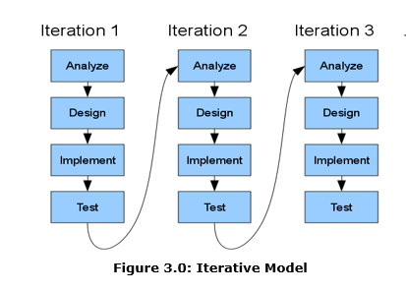

Figure 3.1 Iterative Model

Source: https://capstoneguide.com/wp-content/uploads/2020/08/Iterative-Model-1.png

**Planning Phase**

During this phase, the project's proponents select the project and define their roles and duties inside the system. We hold meetings to discuss the system, distribute work, and do research. Organizing the activities till the project is completed. The proponents decide who will use the system, how it will perform for the user, and how we will collaborate on all projects.

**Analysis Phase**

System analysis involves interviewing the school and analyzing the flow/process of the system as well as the requirements needed to make the project possible. It comprises the software and hardware specifications, as well as selecting the appropriate programming language to be utilized, which will affect the system's functionality and interface.

**Design Phase**

During the design phase, the proponents build the system prototype and the data flow diagram. We utilized a Gantt chart to schedule the tasks required to meet the target goal. The system contains a login screen where the administrator must enter his or her username and password. Then it will take you to the dashboard, where you will see menus from which you can choose your chosen folders.

**Development Phase**

Proponents begin coding in this phase, employing CSS for template design, JQuery for animation, JavaScript for commands, and PHP as a scripting language.

**Testing Phase**

In this phase, the proponents test and debug the system if all the functions are working.

**Implementation Phase**

The system is ready to be utilized. The tests have been done to ensure the quality of the system.

**Maintenance Phase**

They can call or email us if there is an error or difficulty with the system's function that we have implemented.

**User’s Acceptance Survey**

The development system will be subjected to user acceptance testing by the system's users: the company's management or administration, which includes the Finance, Administrative, and Maintenance Departments.

**3.1.1 Requirements Analysis**

* + - 1. **Documentation of the Current System**

The DOrSU-MPC has its own manual-based of keeping records and storage in the computer with the use of Microsoft Excel as a software application. The bookkeeper is assigned and tasked for this job. The bookkeeper manages

the necessary forms in entering the data in the accounting forms and in applying forms. In accounting, the bookkeeper collects the daily cash report of the canteen and also for loan, immediately stored in the computer. Grabbing some data from it would allow formulating data for general ledgers both for the canteen and for loan.

**3.1.1.2 Hardware setup**

A single computer unit is used by the bookkeeper of the cooperative.

**3.1.1.3 Software and Application being Used**

The DOrSU-MPC uses the MS Excel application in entering data and generating reports on accounting and in loan. No other software application is used by the current manual-based system.

**3.1.1.4 Personnel**

Only one person is in-charge in the cooperative; the bookkeeper.

**3.1.2 Requirements Documentation**

**3.1.2.1 System Architecture**

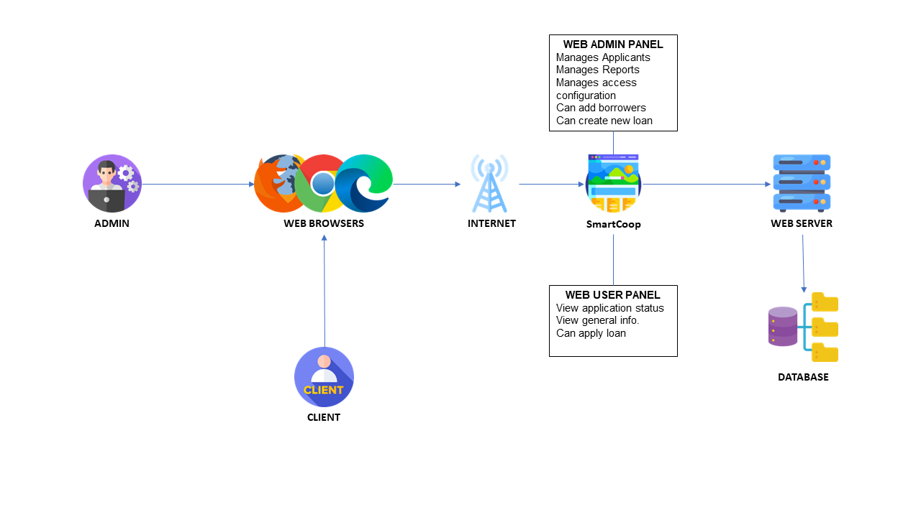 A system architecture is similar to a blueprint that outlines how a system is set up. arranged, functional, and viewed from many perspectives. It is crucial because it improves our comprehension of the system. A thorough explanation of the system's structure and behavior is provided in the architecture description. We can use it to examine the process and reach decisions.

Figure 3.2 System Architecture

Illustrated in Figure 3.2 is the system architecture of SmartCoop System Architecture. Two types of users interact with the system. The first one is the Admin. This type of user manages the applicants, reports and borrowers. Furthermore, this user has access to the entire system. The second type of user is the Client. This user can manage their personal information, their loan request, and status.

**3.1.3 Requirements Specifications**

**3.1.3.1 Product Perspective**

The developers’ project is not considered new technology, although the components utilized to make it did exist previously. This project was designed to expand and innovate the use of technology and to employ the existing algorithm associated with the task better and more efficiently.

**3.1.3.2 Product Features**

The technology enables DOrSU-MPC officials to develop and manage results for managing process. The system may provide a summary of reports such as borrowers' reports, loan reports, financial reports, and administrative reports, this feature will assist them simply improving their method of maintaining records

**3.1.3.3 User Class and Characteristics**

Users of this projects are individuals who work in DOrSU-MPC in terms of updating data on all of the information happening in the cooperative promptly.

**3.1.3.4 Operating Environments**

The developers employed various tools, platforms, and technologies to finish the project. Developers can use these technologies to construct efficient and functional applications. When creating the system, the developers design a web-based system that can run on desktop that require an internet connection to view the data.

**3.1.3.4.1 Software Specifications**

The proponents utilized a variety of software applications as per requirement in developing the system. For the front-end development, the proponents used Visual Studio Code as the text-editing tool in which they employed core technologies in web development like HTML and CSS, partnered with Bootstrap, Materialize CSS, and JavaScript. The proponents used a PHP framework for the back-end development, like laravel, an open-source software responsible for the system's functionality, and MySQL for the system's databases.

**3.1.3.4.2 Hardware Specifications**

The hardware components used in the development and deployment of the system. For the performance and functionality, we dedicated a server it is required to host the web application, with database is recommended for hosting the MySQL database. We access the system from a variety of devices, including but not limited to, desktop computers, laptops, tablets, smartphones. And we use Laptop and computer desktop for editing and developing the web application. The hardware specifications for devices may vary, but they should have modern web browsers capable of rendering HTML, CSS, and JavaScript effectively.

**3.1.3.5 Design and Implementation Constraints**

**3.1.3.6 User Documentation**

The developers allow the user to test and learn how to utilize the system. The proponent uses of visual content such as images to quickly show users how to solve their problems. It would help them be more successful with the project.

**3.1.3.7 Other Non-functional Requirements**

The developers of this web-based system deliver reliable information to the user.

**3.1.3.7.1 Safety Requirements**

**3.1.3.7.2 Security Requirements**

Even though security is critical in system implementation, the designed system is security-friendly. The system has a login feature that requires users to have a personal account to use it, and it will, of course, you have the password for you to proceed. Furthermore, developers don’t include any monetary transactions just like online payment transaction in the web-system to prevent scams and fraudulent behavior.

**3.1.3.7.3 Software Quality Attributes**

* + 1. **Design**

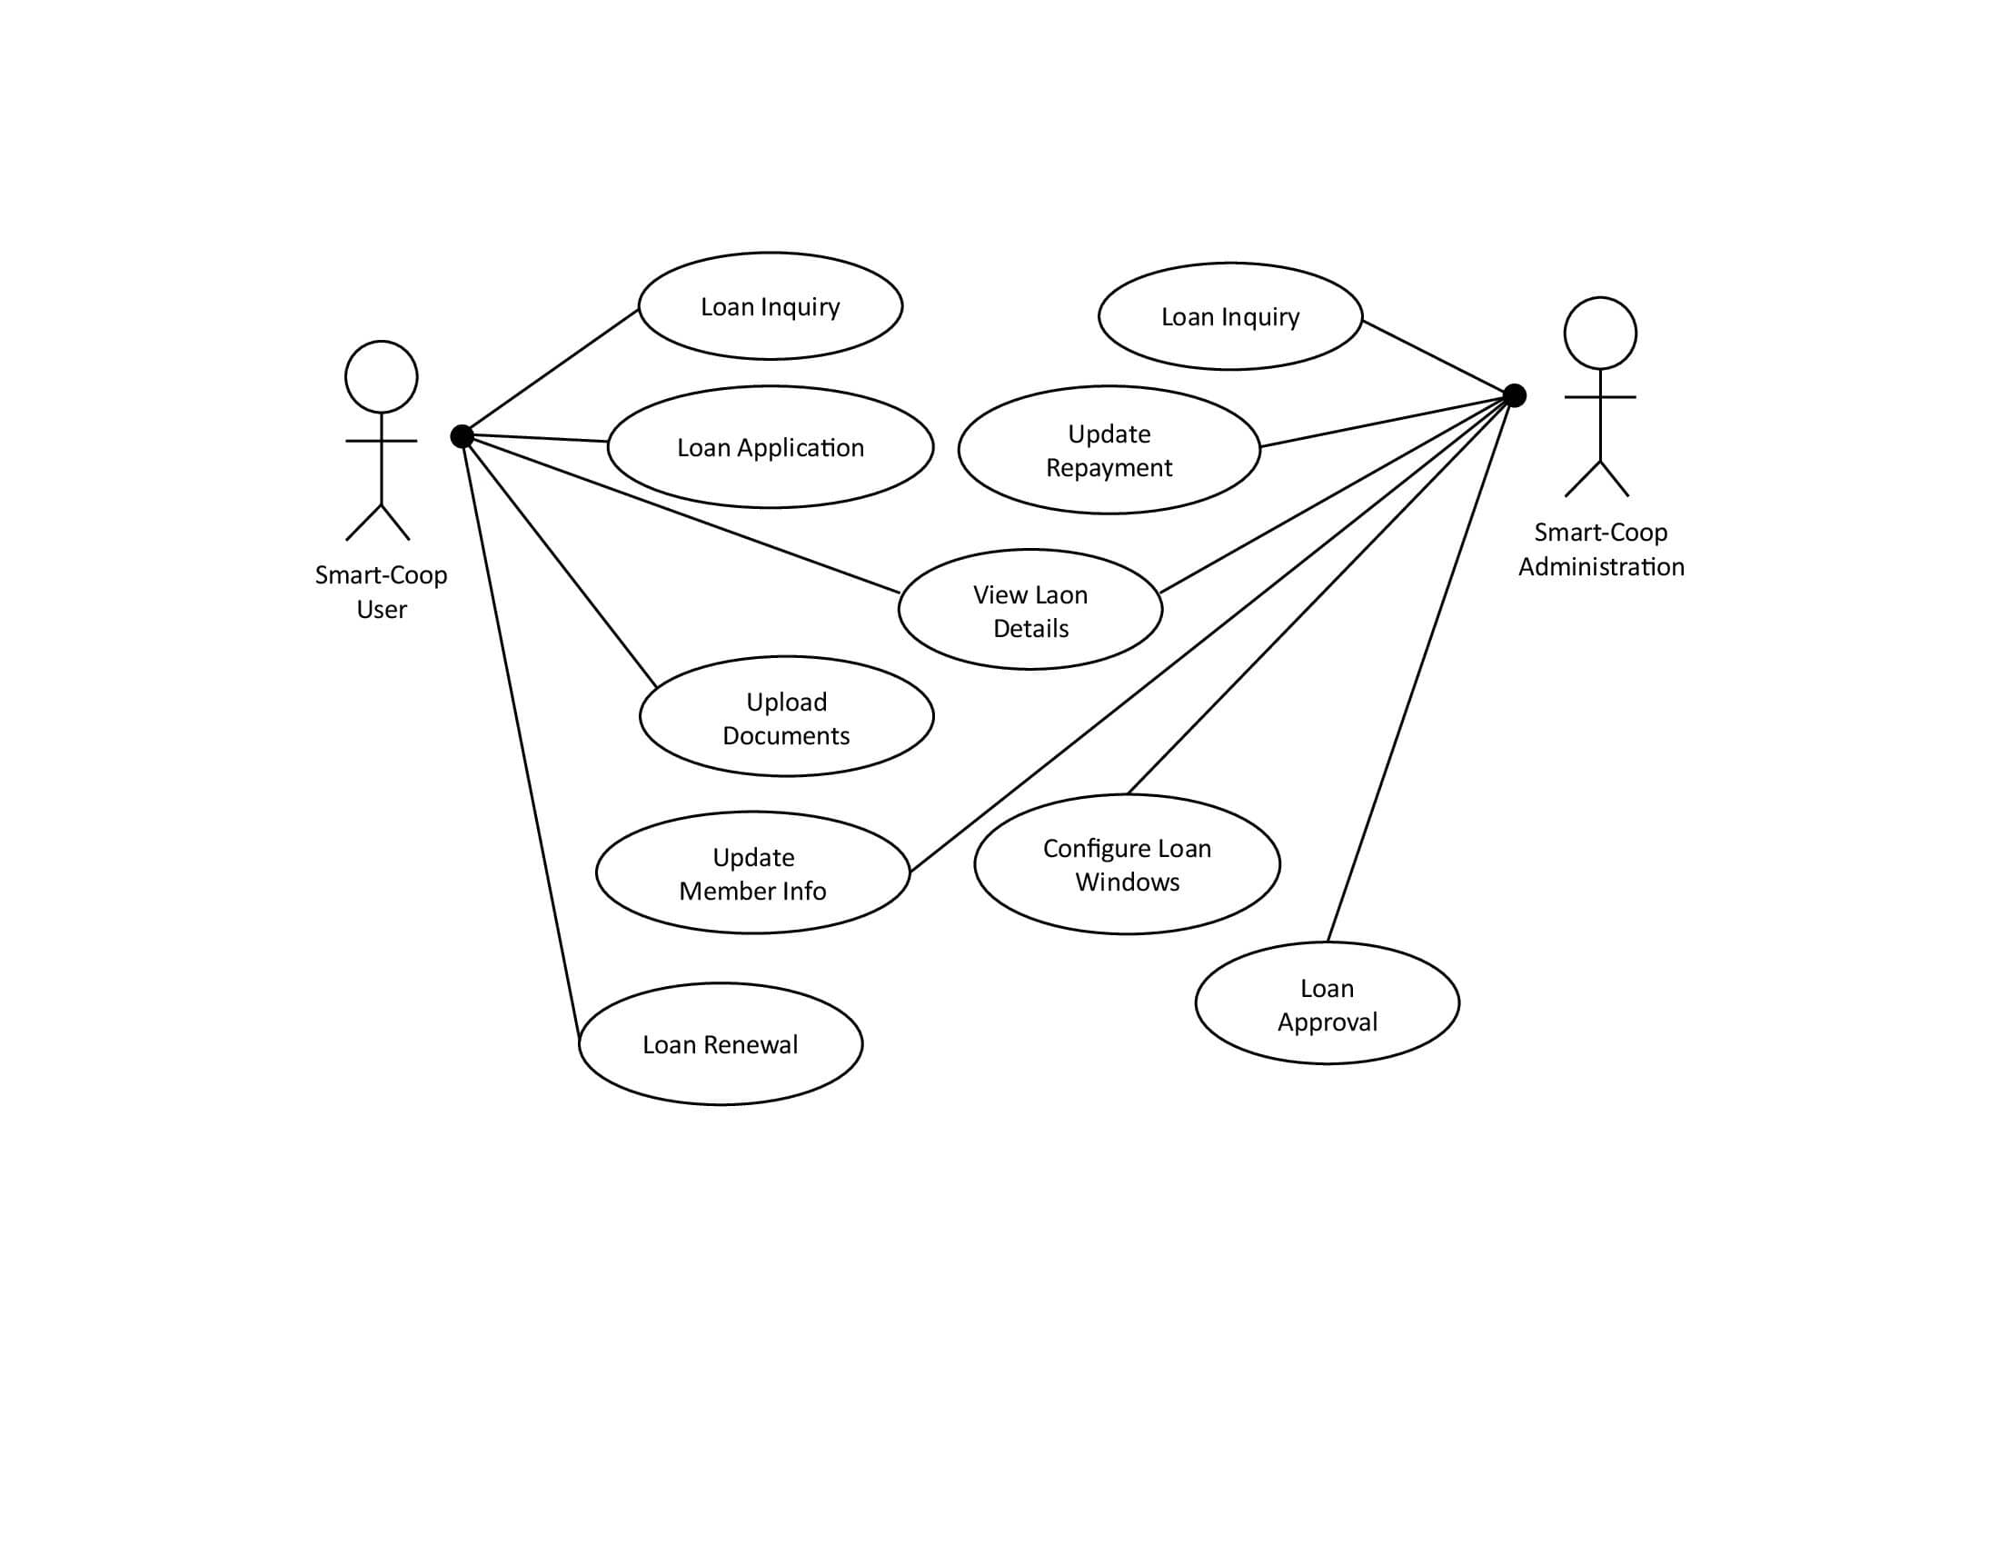**3.1.4.1 Use Case Diagram**

**3.1.4.1.1Use Case Description**

The use case diagram illustrates the system’s interactions with its users and outlines the actions within the system. It involves two external actors: Smart-Coop user and Smart-Coop Administration, each with distinct access privileges. The approval of loans is a shared responsibility between the Administration and the Credit Committee, while users primarily have access to modules related to loan applications. The administration, on the other hand, is responsible for administrative tasks such as loan processing, generating reports, and managing loan windows.

**3.1.4.2 Entity Relationship Diagram**

**3.1.4.3 Data Dictionary**

**3.1.4.4 Graphical User Interface Designs**

**3.1.5 Development and Testing**

**3.2 Mock-up**

The figures below show the interface in which End-Users are able to do their respective operations. This includes dashboard, borrowers, loans, repayments, reports, access configuration, user log, settings, and my profile.

**3.2.1 Admin View**

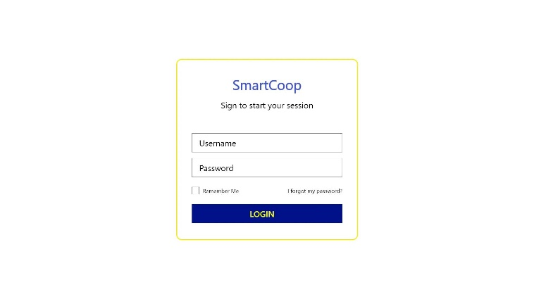

1

2

3

4

5

*Figure 3.2 Admin Login Interface*

Table 3.1 Admin Login Interface

|  |  |  |  |
| --- | --- | --- | --- |
| **No.** | **UI Component** | **Name** | **Description** |
| 1 | Text field | Username | This will enable the administrator to type his/her username |
| 2 | Text field | Password | This will enable the administrator to type his/her password |
| 3 | Button | Recovery | It allows administrator to recover or change password |
| 4 | Checkbox | Saved | It allows sessions to remember your username and password |
| 5 | Button | Login | This will enable the administrator to log in |

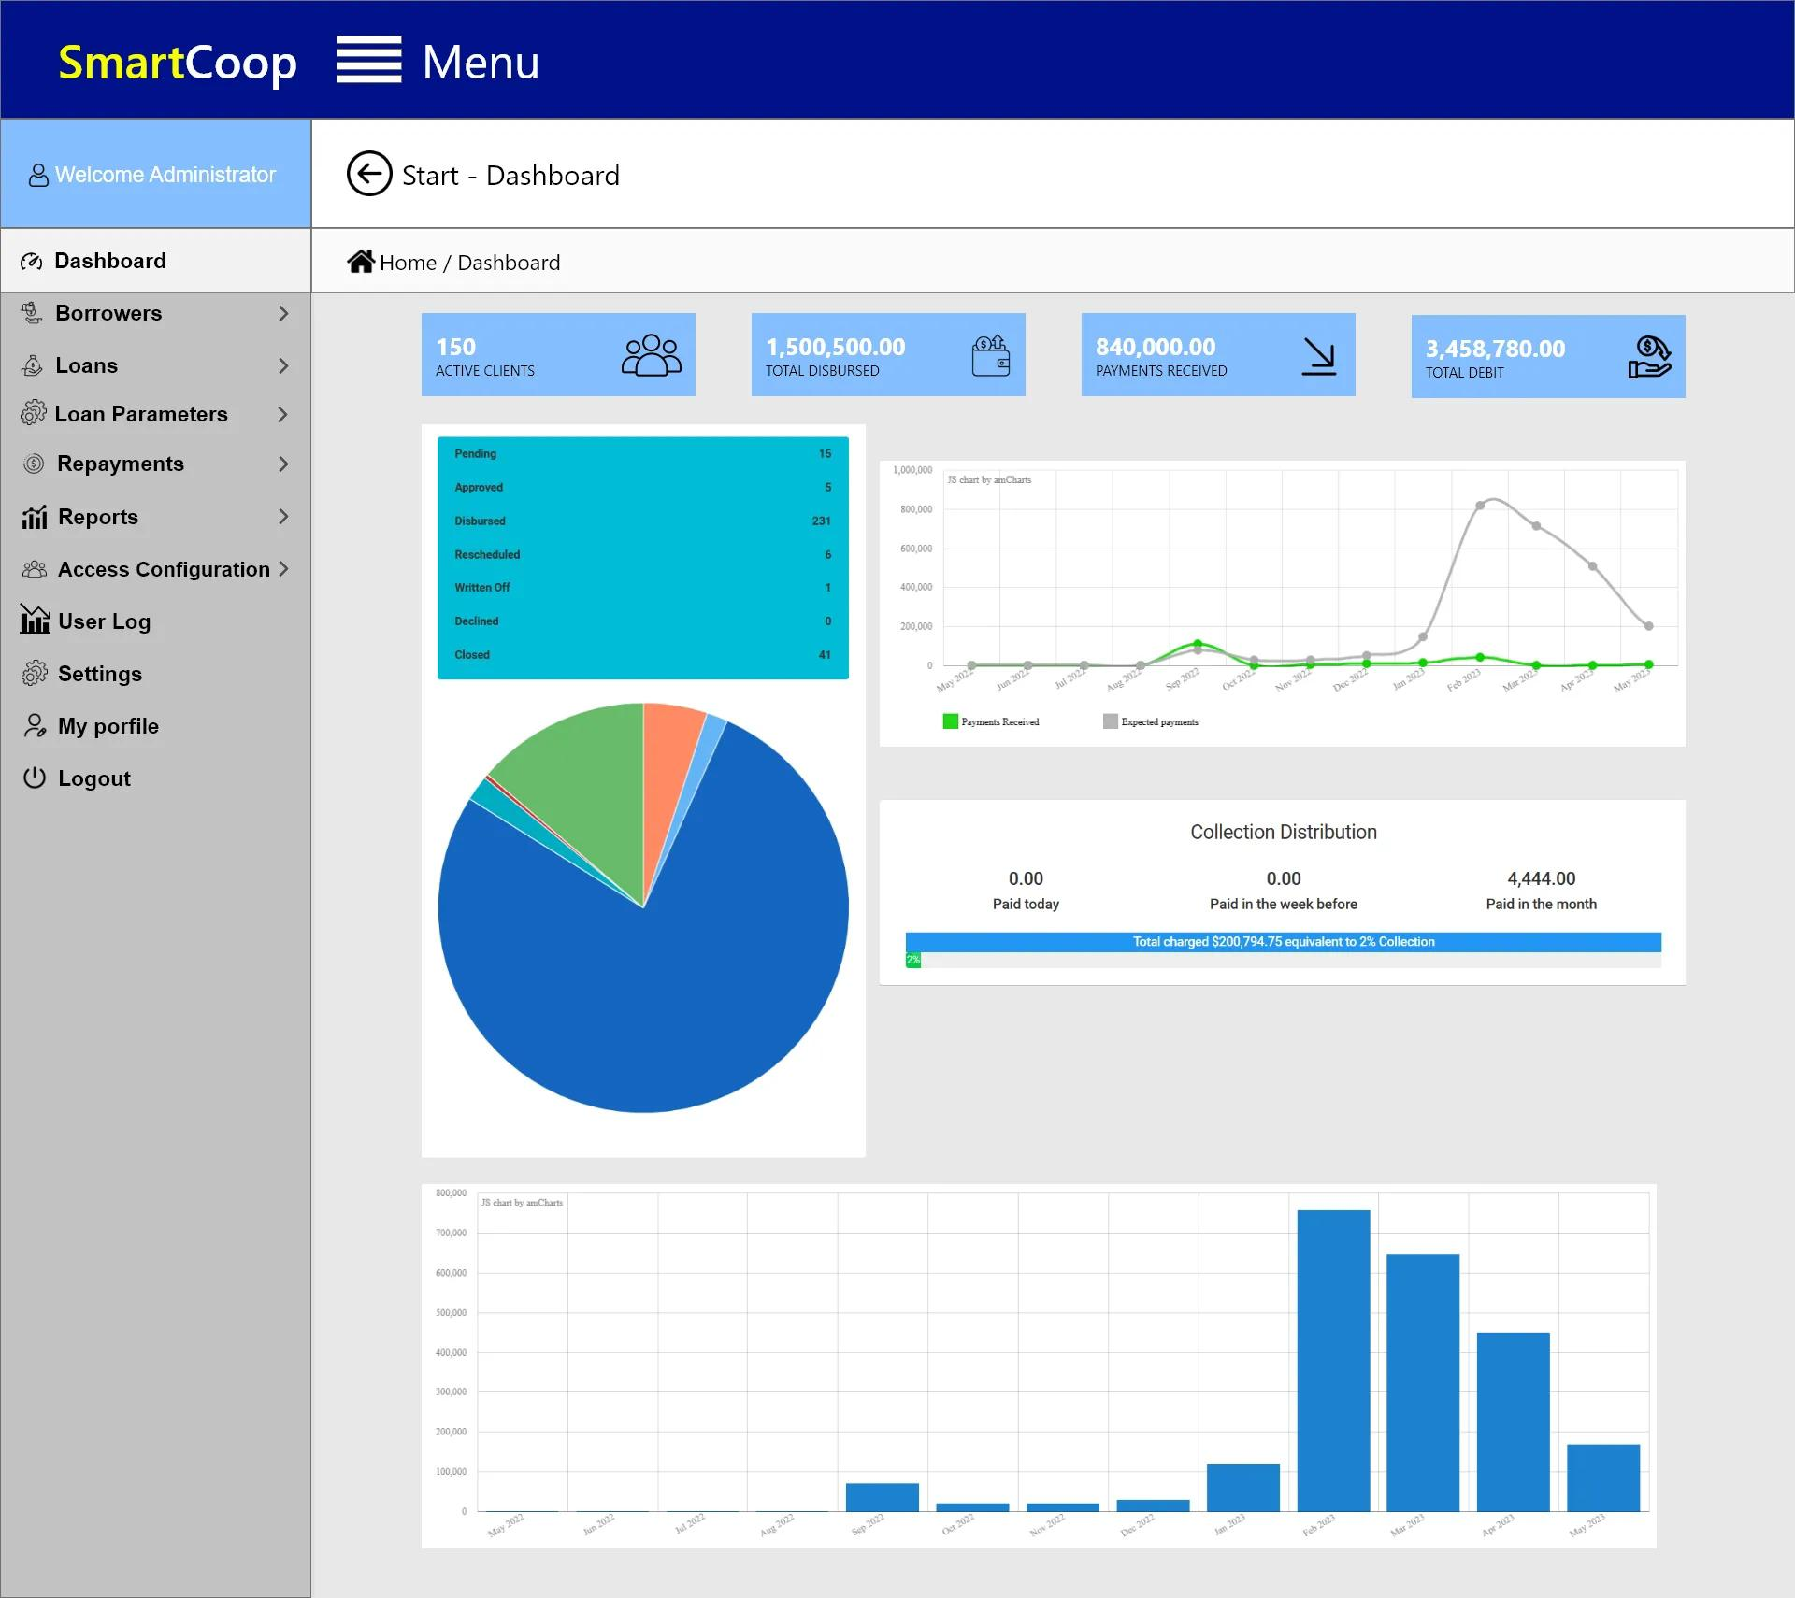

1

2

3

*Figure 3.3 Admin Dashboard Interface*

Table 3.2 Admin Dashboard Interface

|  |  |  |  |
| --- | --- | --- | --- |
| **No.** | **UI Component** | **Name** | **Description** |
| 1 | Navigation | Menu | This enables page navigation for the administrator |
| 2 | Button/Icon | Back | Allow the user to go back to the previous page opened |
| 3 | Cards | Summary | The system displays the summarized numbers report |

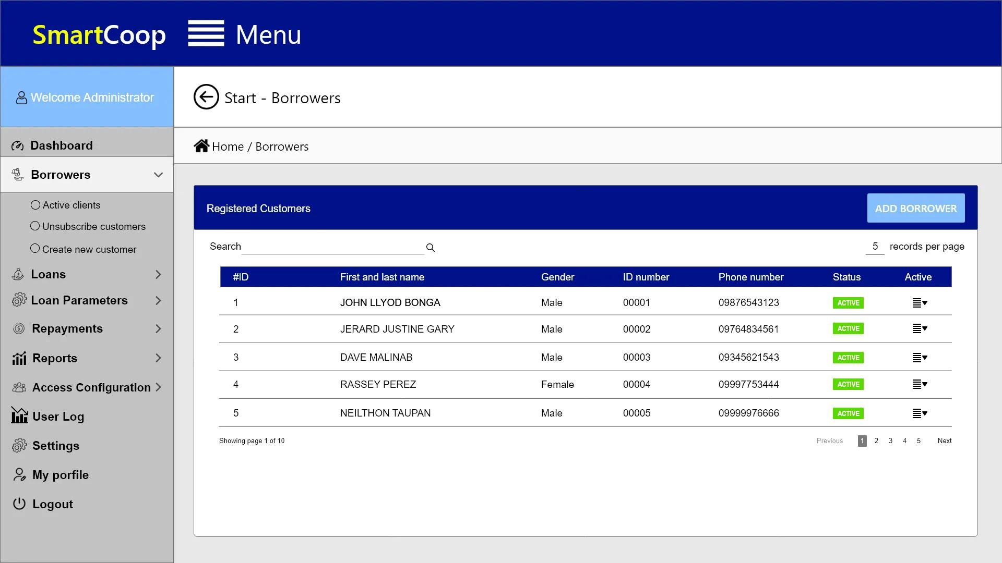

1

2

3

4

5

6

*Figure 3.4 Borrower’s Interface*

Table 3.3 Borrower’s Interface

|  |  |  |  |
| --- | --- | --- | --- |
| **No.** | **UI Component** | **Name** | **Description** |
| 1 | Radio buttons | Types | Allow admin presenting a limited types of choices at a time. |
| 2 | Dropdown | Menu | Expands or hide to display a list of options for admin user |
| 3 | Text field | Search | Enable the admin users to enter their search query into the text field |
| 4 | Button | Add Borrower | This allows the administrator to add a new borrower |
| 5 | Button | Page Selection | This will enable the administrator to open another page or a selected page |
| 6 | Dropdown | Active | Allows the administrator to modify the status of a specific user |

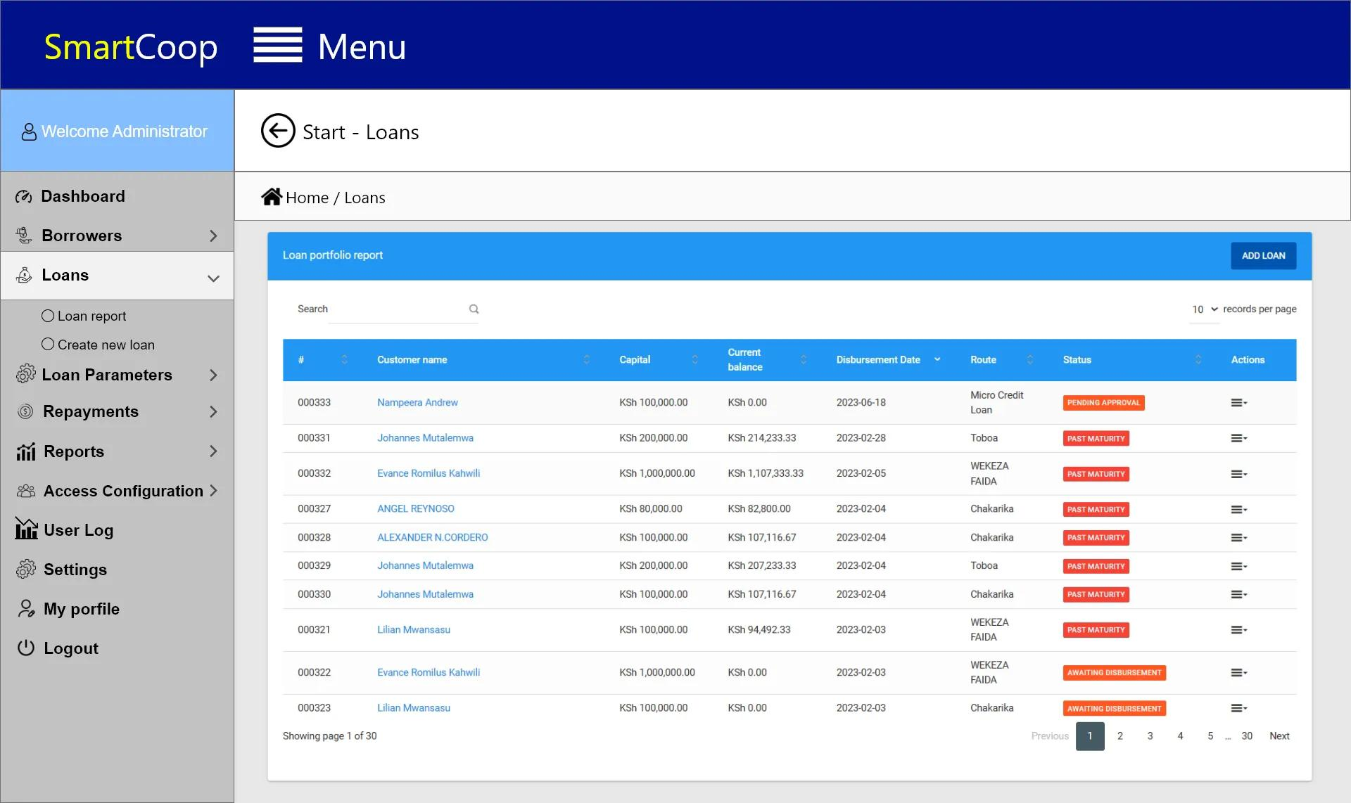

1

2

3

4

5

*Figure 3.5 Loan’s Interface*

Table 3.4 Loan’s Interface

|  |  |  |  |
| --- | --- | --- | --- |
| **No.** | **UI Component** | **Name** | **Description** |
| 1 | Text field | Search | Enable the admin users to enter their search query into the text field |
| 2 | Dropdown | Records per page | Admin can control the pagination of the data |
| 3 | Button | Add Loan | This allows the administrator to add a new loan |
| 4 | Button | Page Selection | This will enable the administrator to open another page or a selected page |
| 5 | Dropdown | Actions | To modify or update its contents |

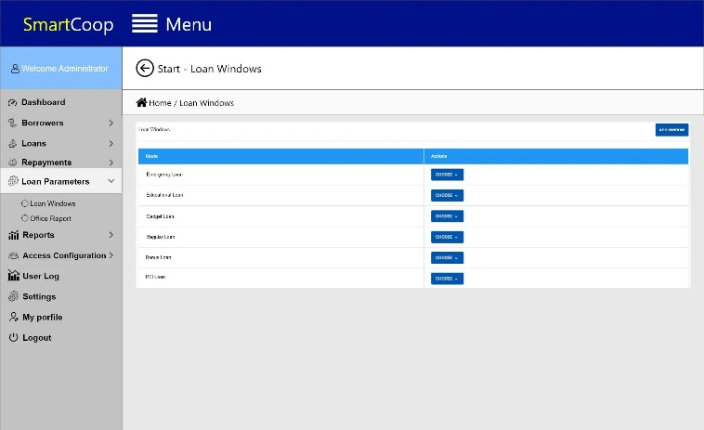

1

2

*Figure 3.6 Loan Parameters Interface*

Table 3.5 Loan Parameters Interface

|  |  |  |  |
| --- | --- | --- | --- |
| **No.** | **UI Component** | **Name** | **Description** |
| 1 | Button | Add Window | Allow the creation of a new loan parameter window in the admin panel |
| 2 | Dropdown Button | Action | Allow admins to access various actions related to managing loan windows |

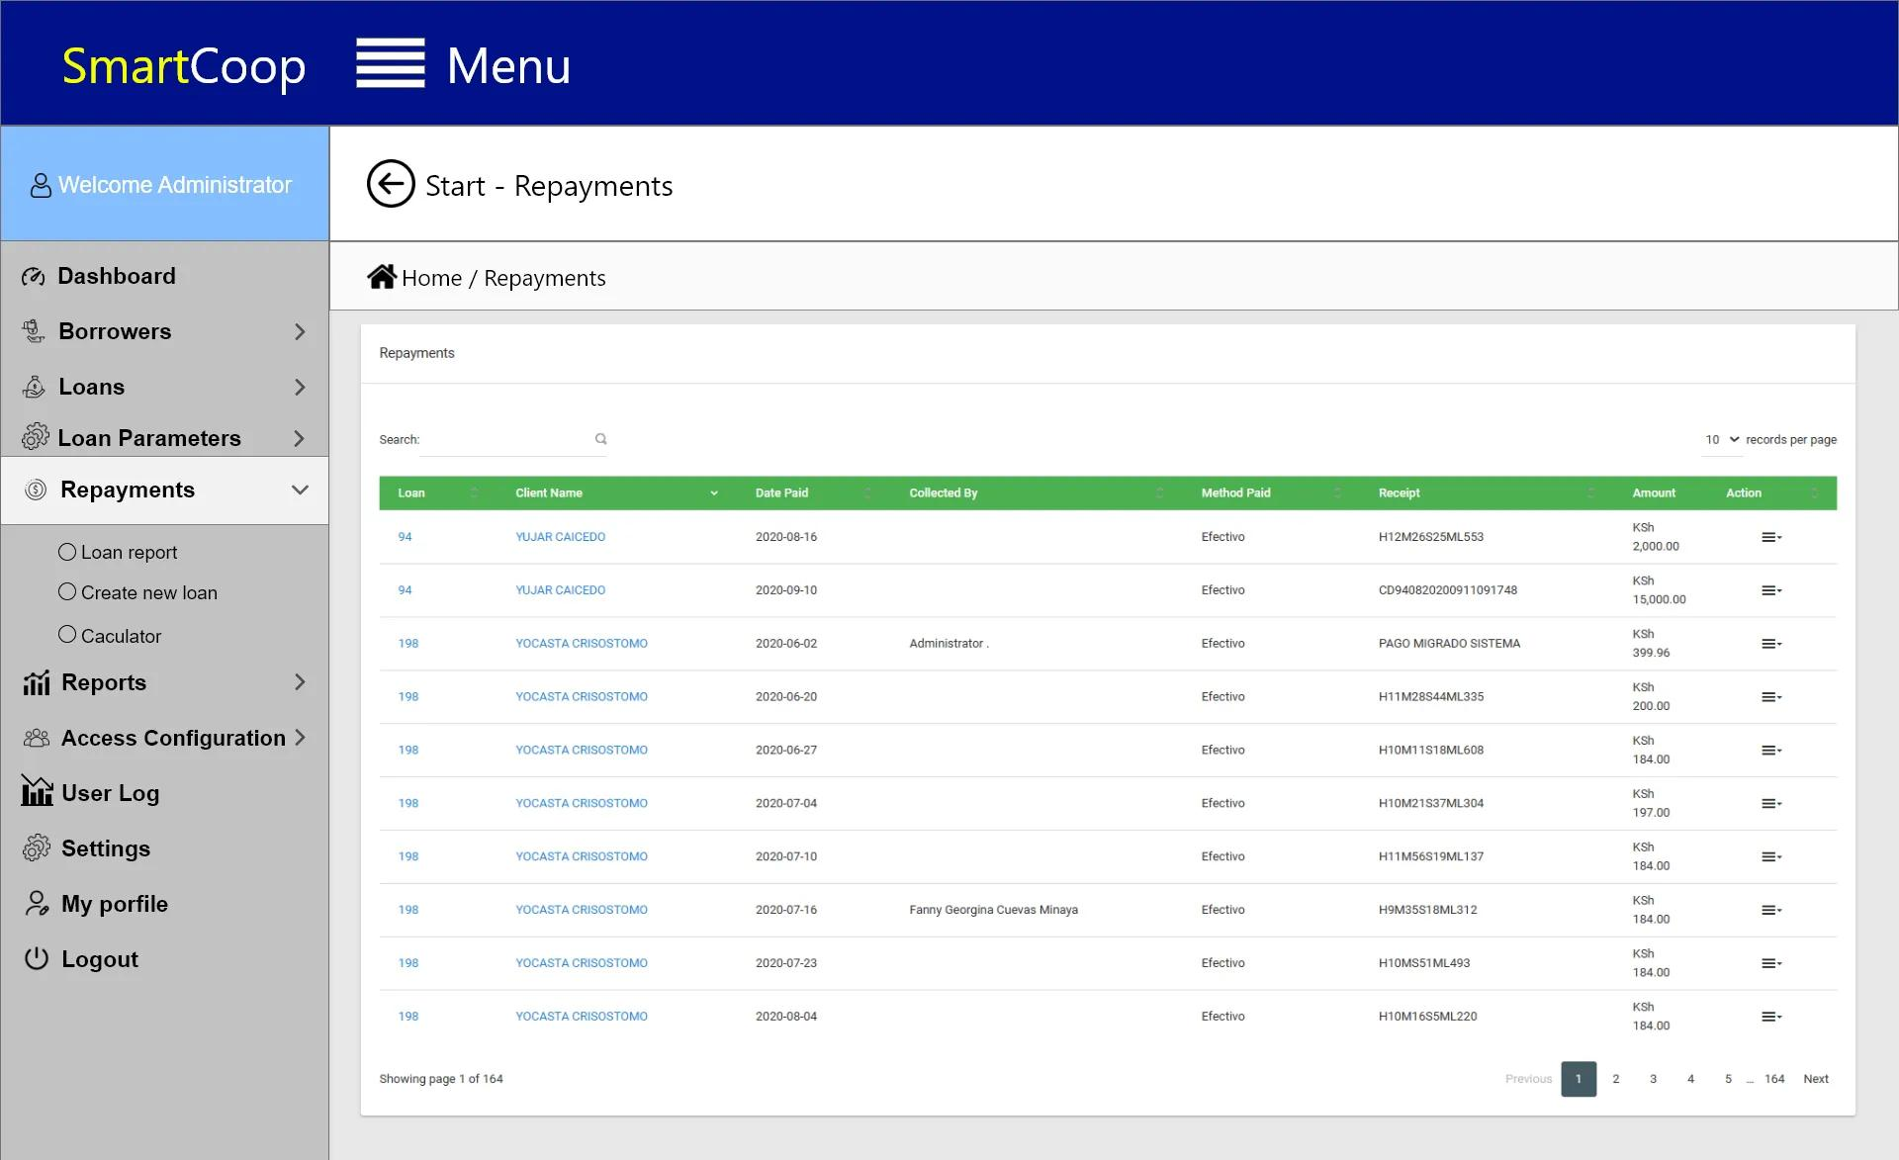

1

2

3

4

*Figure 3.7 Repayment’s Interface*

Table 3.6 Repayment’s Interface

|  |  |  |  |
| --- | --- | --- | --- |
| **No.** | **UI Component** | **Name** | **Description** |
| 1 | Text field | Search | Enable the admin users to enter their search query into the text field |
| 2 | Dropdown | Records per page | Admin can control the pagination of the data |
| 3 | Button | Page Selection | This will enable the administrator to open another page or a selected page |
| 4 | Dropdown | Actions | To modify or update its contents |

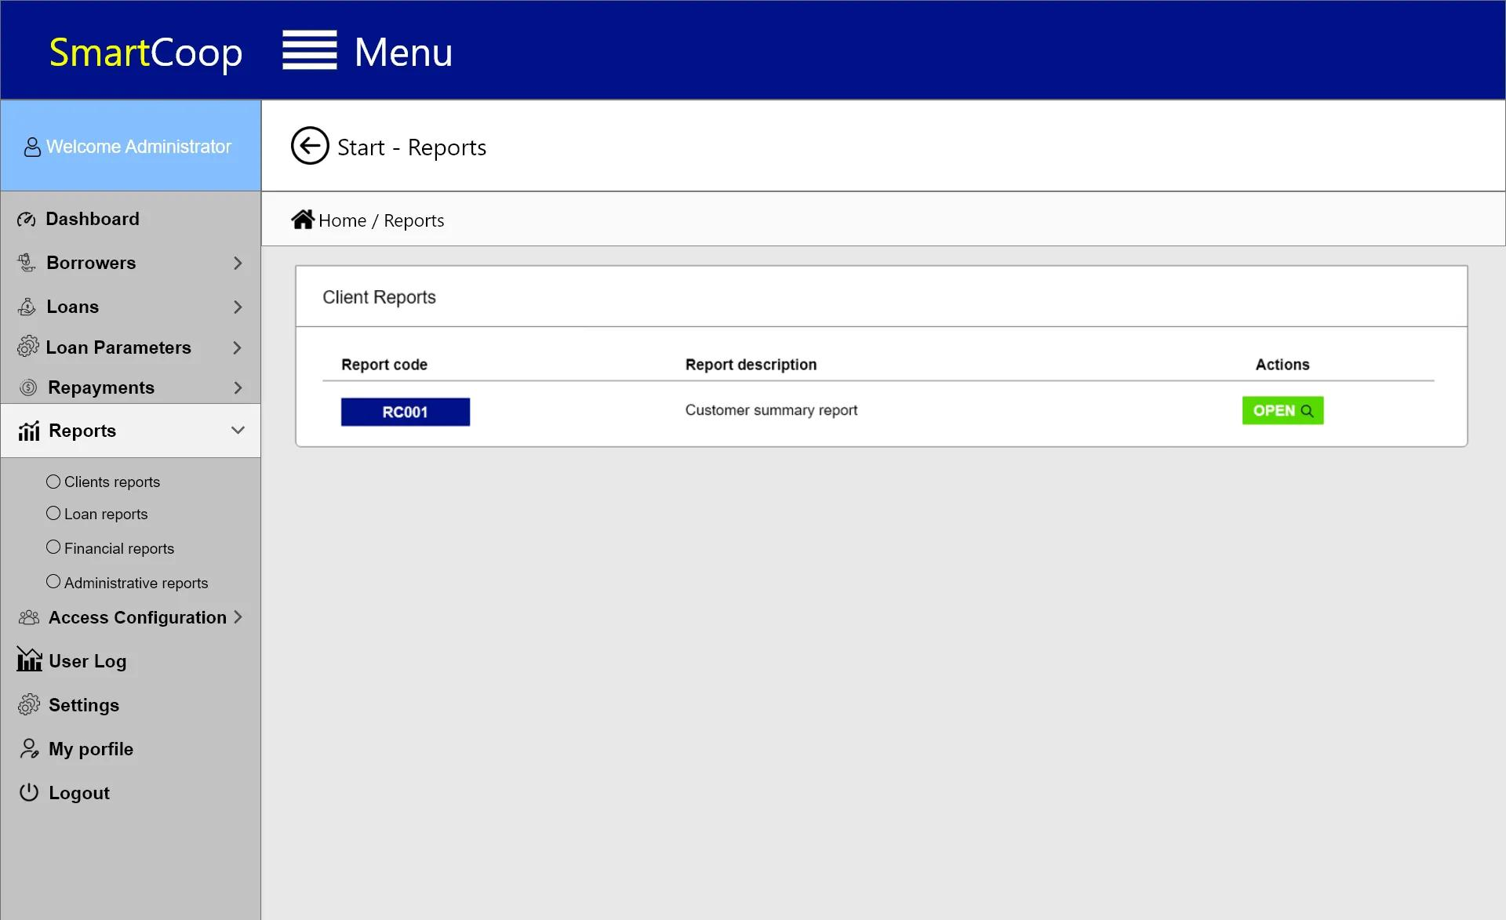

1

2

*Figure 3.8 Report’s Interface*

Table 3.7 Report’s Interface

|  |  |  |  |
| --- | --- | --- | --- |
| **No.** | **UI Component** | **Name** | **Description** |
| 1 | Text | Report Code | Unique identity of a data |
| 2 | Button | Open Report | It allows the administrator to view client report |

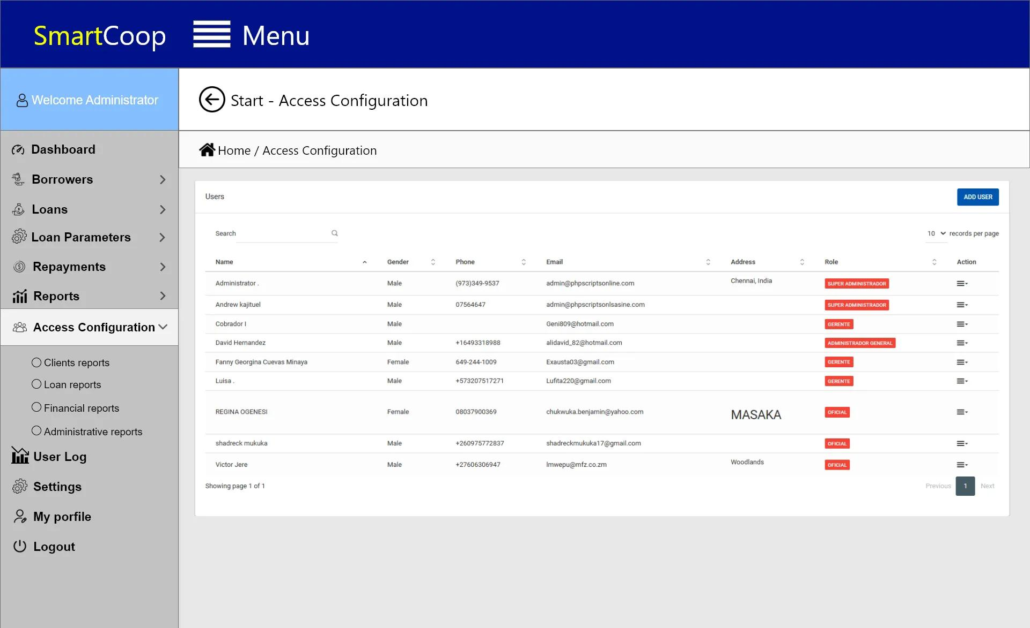

1

2

3

4

5

6

*Figure 3.9 Access Configuration’s Interface*

Table 3.8 Access Configuration’s Interface

|  |  |  |  |
| --- | --- | --- | --- |
| **No.** | **UI Component** | **Name** | **Description** |
| 1 | Text field | Search | Enable the admin users to enter their search query into the text field |
| 2 | Dropdown | Sort | Allows users to choose from a predefined list |
| 3 | Dropdown | Records per page | Admin can control the pagination of the data |
| 4 | Button | Add user | This allows the administrator to add a new user |
| 5 | Button | Page Selection | This will enable the administrator to open another page or a selected page |
| 6 | Dropdown | Actions | To modify or update its contents |

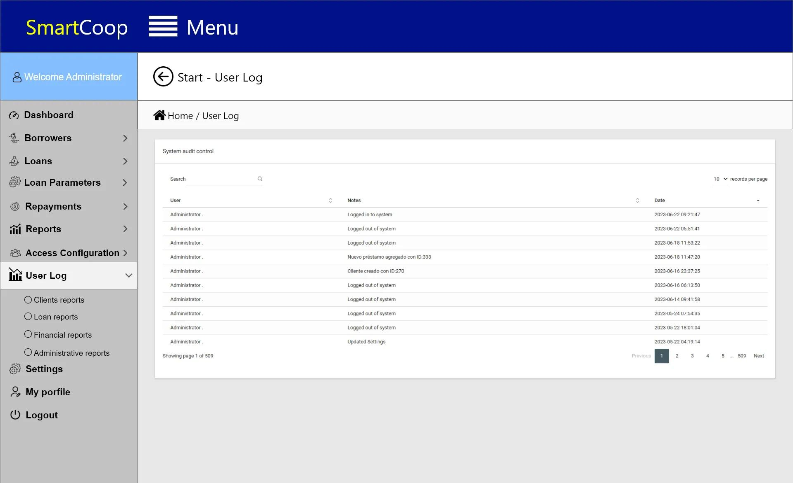

1

2

3

4

*Figure 3.10 User Log’s Interface*

Table 3.9 User Log’s Interface

|  |  |  |  |
| --- | --- | --- | --- |
| **No.** | **UI Component** | **Name** | **Description** |
| 1 | Text field | Search | Enable the admin users to enter their search query into the text field |
| 2 | Dropdown | Sort | Allows users to choose from a predefined list |
| 3 | Dropdown | Records per page | Admin can control the pagination of the data |
| 4 | Button | Page Selection | This will enable the administrator to open another page or a selected page |

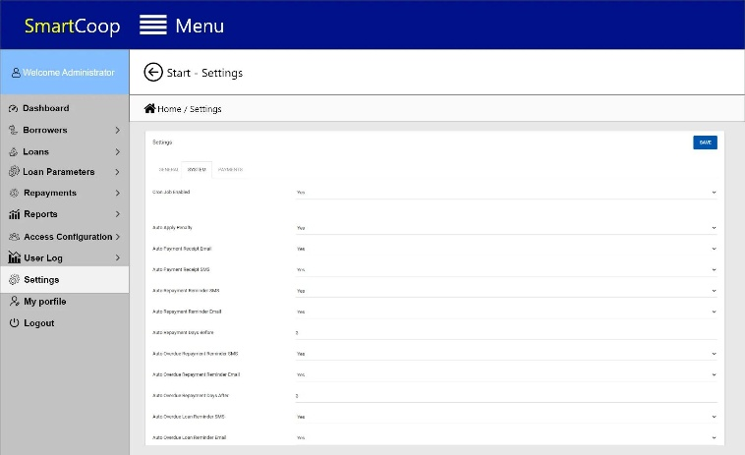

2

1

3

*Figure 3.11 Setting’s Interface*

Table 3.10 Setting’s Interface

|  |  |  |  |
| --- | --- | --- | --- |
| **No.** | **UI Component** | **Name** | **Description** |
| 1 | Button | Save | Allow admin to safeguard your preferences and changes by securely storing them |
| 2 | Dropdown | Choices | Allow the admin to Select from a range of options that suit their preferences |
| 3 | Tabs | Settings | Switch between different sections, such as General Settings, System Settings, and Payment Settings |

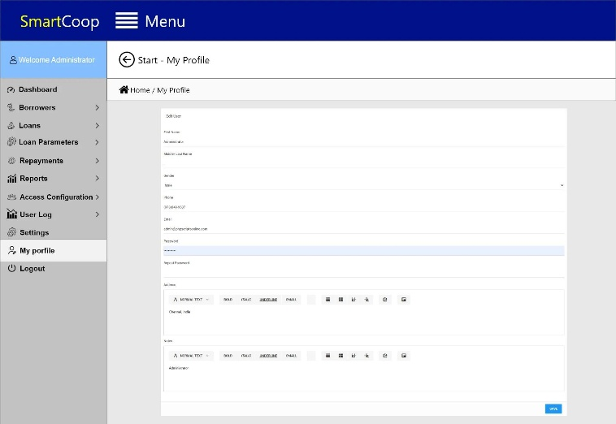

2

3

4

5

6

7

8

1

*Figure 3.12 My Profile’s Interface*

Table 3.11 My Profile’s Interface

|  |  |  |  |
| --- | --- | --- | --- |
| **No.** | **UI Component** | **Name** | **Description** |
| 1 | Text Field | Edit User | Can provide key details about themselves |
| 2 | Dropdown | Gender | Admin can effortlessly select their gender preference |
| 3 | Dropdown Button | Text Style | An array of stunning text styles |
| 4 | Button | BIUS | Transform ordinary text into extraordinary expressions |
| 5 | Button | Bullets and Paragraph | Allow admin to effortlessly capture and categorize information. |
| 6 | Button | Share | Allowing admins to instantly share content or information |
| 7 | Button | Upload Image | Allow admin to upload images with ease |
| 8 | Button | Save | Provide admins with a convenient and efficient way to save their profile changes |

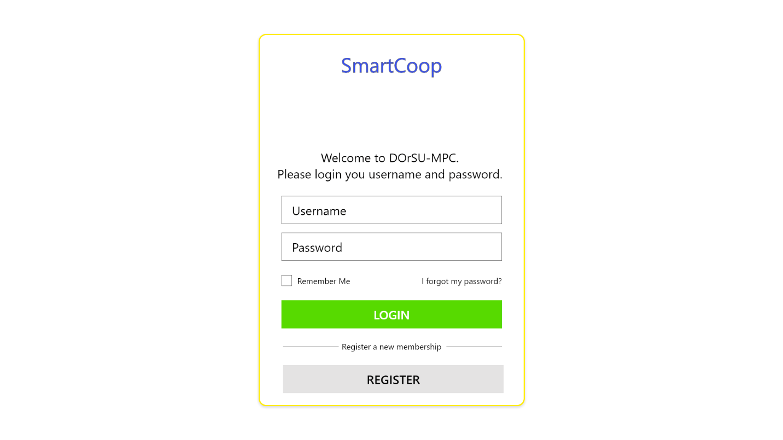**3.2.2 Client View**

*Figure 3.6 Client Sign in Interface*

Table 3.12 Client Sign in Interface

|  |  |  |  |
| --- | --- | --- | --- |
| **No.** | **UI Components** | **Name** | **Description** |
| 1 | Text | SmartCoop | This represents the name of the system |
| 2 | Text field | Username | This will enable the user to type his/her username |
| 3 | Text field | Password | This will enable the user to type his/her password |
| 4 | Checkbox | Saved | It allows sessions to remember your username and password |
| 5 | Button | Recovery | It allows user to recover or change password |
| 6 | Button | Login | This will enable the administrator to log in |
| 7 | Button | Register | This will enable a new user to create or register an account |

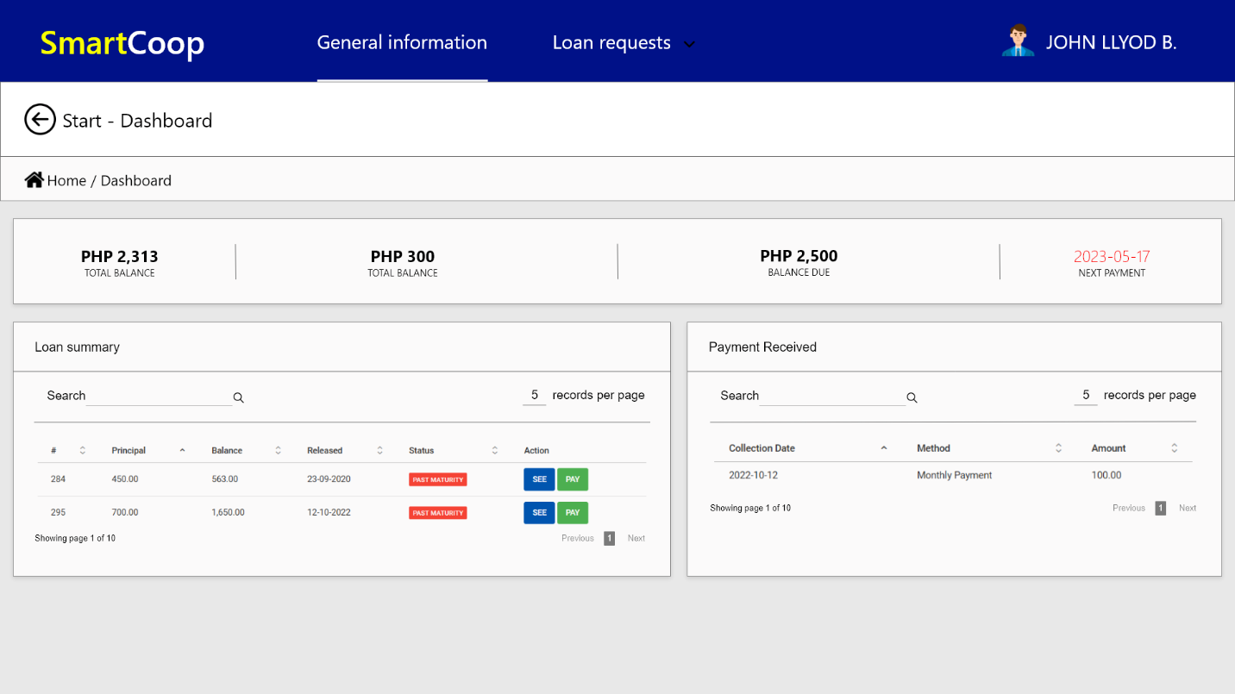

*Figure 3.7 Client Dashboard Interface*

Table 3.13 Client Dashboard Interface

|  |  |  |  |
| --- | --- | --- | --- |
| No. | UI Components | Name | Description |
| 1 | Text | Logo | The Logo represents the system |
| 2 | Tooltip | General Information | This will enable the user to view all the loan information |
| 3 | Tooltip | Loan request | This enables the user to request and view the available loans |
| 4 | Button and Image | Profile | It allows the user to view his/her profile |

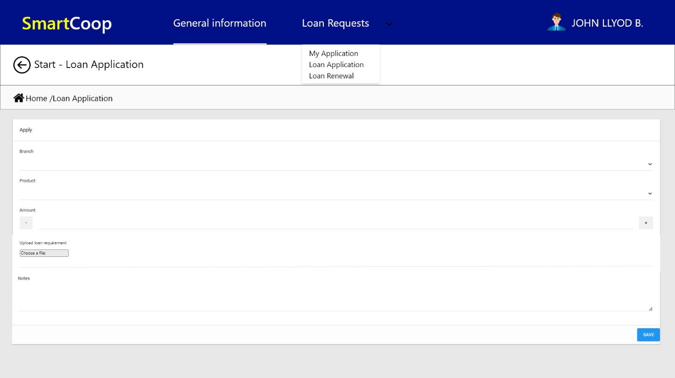

*Figure 3.7 Loan Application Interface*

Table 3.14 Loan Application Interface

|  |  |  |  |
| --- | --- | --- | --- |
| No. | UI Components | Name | Description |
| 1 | Drop down | List | This allows the user to see the list on the types of loans offered |
| 2 | Drop down | List | This will allow the user to setup some info in making a loan |
| 3 | Button | Save | This will allow the user to save his/her information for the loan |

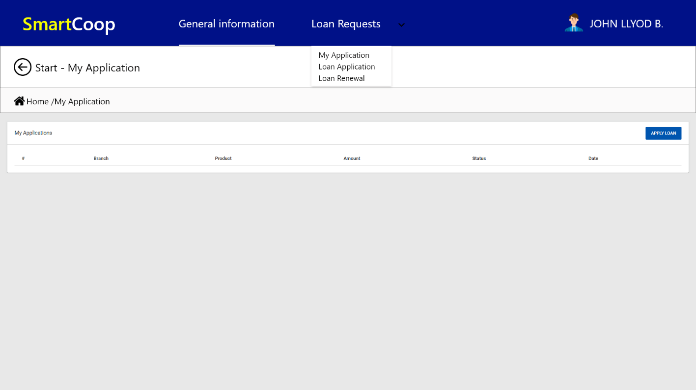

*Figure 3.7 My Application Interface*

Table 3.14 My Application Interface

|  |  |  |  |
| --- | --- | --- | --- |
| No. | UI Components | Name | Description |
| 1 | Text field | Text Entry | This enables the user to track their progress |
| 2 | Button | Apply Loan | This will allow the user to apply for the loan he/she filled up |

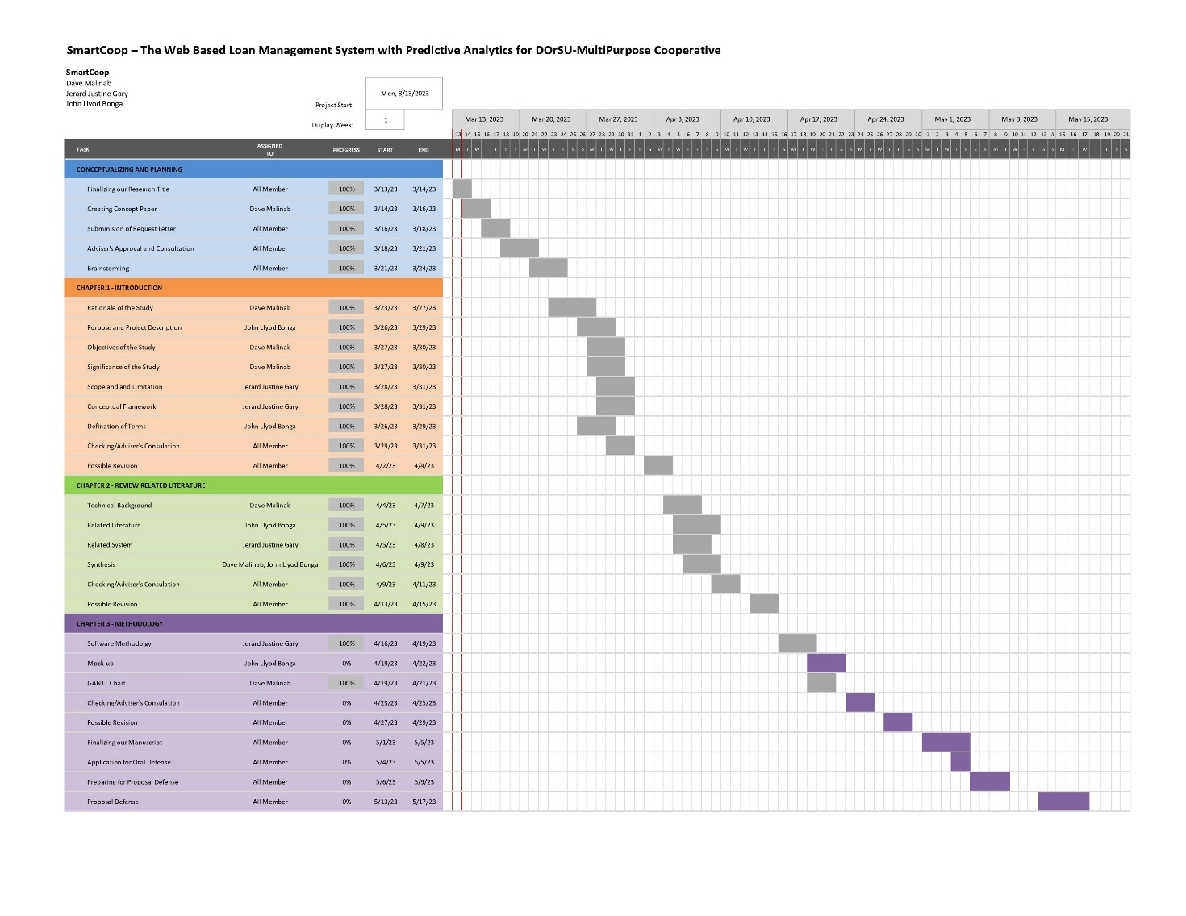**GANTT CHART**

**LITERATURE CITED**

Aezion Inc. (2021) The benefits of web-based systems for business. Aezion Inc. Retrieved from: <https://www.aezion.com/blogs/the-benefits-of-web-based-systems-for-business/?amp=1>

Barik R., & Mishra A., (2017) Importance of database design in loan management systems: A case study using MySQL. Retrieved from: International Journal of Computer Applications, 162(11), 33-37

Bhagwatsaran, (2015) Postbank’s Loan Management System Retrieved from: <https://capstoneguide.com/multi-purpose-cooperative-loan-management-system-capstone-project-document/>

Bootstrap. (n.d.) Homepage. Retrieved from: <https://getbootstrap.com>

Bragg S., (2020) Financial Reporting. Accounting Tools. Retrieved from: <https://www.accountingtools.com/articles/what-is-financial-reporting.html>

BTOES Insights. (n.d.) What is data analytics? [Blog post]. Retrieved from <https://insights.btoes.com/what-is-data-analytics>

Capstone Guide. (2020) Multi-Purpose Cooperative Loan Management System Capstone Project Document. Retrieved from: <https://capstoneguide.com/multi-purpose-cooperative-loan-management-system-capstone-project-document/>

Cerquit Loans Developer. (2013) Ever First Loan Corporation Loan Management System. Retrieved from: <https://capstoneguide.com/multi-purpose-cooperative-loan-management-system-capstone-project-document/>

CI&T United States. (2014). The four types of analytics. [http://www.ciandt.com/card/four- types-of-](http://www.ciandt.com/card/four-%09types-of-)analytics-and-cognition

Code Institute. (2021) What Is PHP Programming? Retrieved from: <https://codeinstitute.net/global/blog/what-is-php-programming/>

Desai V., & Mellor R., (1993) Managing multiple lines of credit: Costs and benefits. Retrieved from: Journal of Small Business Management, 31(4), 63-70

DevOps School. (n.d.) What is XAMPP and How to Install XAMPP? DevOps School. Retrieved from: <https://www.devopsschool.com/blog/what-is-xampp-and-how-to-install-xampp/>

Federal Reserve Bank of New York. (2021) Household Debt and Credit Report. Retrieved from: <https://www.newyorkfed.org/microeconomics/hhdc.html>

Funa J.V., (2018) Philippine Financial Reporting Standards. Philippine Institute of Certified Public Accountants. Retrieved from: <https://www.picpa.com.ph/career-pathways/philippine-financial-reporting-standards>

Goyal A., (2021) BUSINESS ANALYTICS, BACKBONE OF ORGANIZATIONS. Retrievedfrom:<https://archives.palarch.nl/index.php/jae/article/download/9894/9093/19369>

InfoWorld. (2021) What is Visual Studio Code: Microsoft’s extensible code editor. Retrieved from: <https://www.infoworld.com/article/3666488/what-is-visual-studio-code-microsofts-extensible-code-editor.html>

Kagan J., (2020) Loan Investopedia. Retrieved from: <https://www.investopedia.com/terms/l/loan.asp>

Kaur, P., Stoitzfus, J., & Yellapu, J. (2018). Descriptive statistics. International journal of academic medicine, 4(1). 60 – 63.

Khairnar P., et. al., (2014) Loan Prediction System Using Random Forest Algorithm Retrieved from: <https://www.jetir.org/papers/JETIR2204641.pdf>

Haas, P., Maglio, P. P., Selinger, P. G., & Tan, W. (2011). Data is dead. without “what-if’ models”. IBM Research, Almaden & UC Santa Cruz. In Proceedings of Very Large Data Bases Endowment, 2, 42 – 55.

Ingram Micro Advisor. (2018). Four types of big data analytics and examples of their use. <http://www.ingrammicro1advisor.com/data-center/four-types-of-big-data-> analyticsandexamples-of-their-use

Lincoln & Nebrasca, (2011) Mortech Loan Management System. Retrieved from: <https://capstoneguide.com/multi-purpose-cooperative-loan-management-system-capstone-project-document/>

Lipana I., & Co., (2020) Financial report system. Retrieved from: [Isla Lipana & Co./PwC Philippines celebrates 100 years of trusted service](https://www.pwc.com/ph/en/news/2022/isla-lipana-pwc-ph-celebrates-100-years-of-trusted-service.html)

Lismont, J. Vanthienen, B. Baesens, & W. Lemahieu. (2017). Defining analytics maturity indicators: A survey approach. International journal of information management, 37(3), 14- 124

MDN web docs. (2020) JavaScript. Retrieved from: <https://developer.mozilla.org/enUS/docs/Web/JavaScript>

Morris, A. (2021). Descriptive Analytics defined: Benefits & Examples. Oracle NetSuite.

<https://www.netsuite.com/portal/resource/articles/erp/descriptive-analytics.shtml>

Muller, O. Fay, M. & Vom Brocke. J. (2018). The effect of big data and analytics on firm performance: An econometric analysis considering industry characteristics. Journal of Management Information Systems, 25(2), 488–509.

National Small Business Association. (2020) NSBA 2020 Year-End Economic Report. Retrieved from: <https://www.nsba.net/wp-content/uploads/2021/01/2020-Year-End-Economic-Report.pdf>

Net Solutions. (n.d.) What is PHP? Insights. Retrieved from: <https://www.netsolutions.com/insights/what-is-php/#:~:text=PHP%20is%20a%20server%2Dside,in%20the%20web%20development%20world>

Nombor R. A., (2020). FINALE: Web-based loan processing system [PDF]. Retrieved from: <https://www.scribd.com/document/576427916/FINALE-WEB-BASED-LOAN-PROCESSING-SYSTEM>

Palmer J., (2020) International Financial Reporting Standards (IFRS). Investopedia. Retrieved from <https://www.investopedia.com/terms/i/ifrs.asp>

Pandey A., Agrawal A., Dubey A. K., Bhatt N., & Yadav U., (2021)., Online Loan Management System. Retrieved from: <https://ijirt.org/master/publishedpaper/IJIRT152063_PAPER.pdf>

Panther International. (2012) Black Cat Loan Management System. Retrieved from: <https://capstoneguide.com/multi-purpose-cooperative-loan-management-system-capstone-project-document/>

Peterson D., (2017) Maximize Efficiency: How Automation Can Improve Your Loan Origination Process. Retrieved from: <https://www.moodysanalytics.com/-/media/whitepaper/2017/maximize-efficiency-how-automation-can-improveyour-loan-origination-process.pdf>

Priya R., & Durgadevi S., (2021) Integrated web-based loan management system using PHP and MySQL. Retrieved from: <https://www.semanticscholar.org/paper/INTEGRATED-WEB-BASED-LOAN-MANAGEMENT-SYSTEM-USING-Priya-Durgadevi/05ac582f7829fd1db427b5b939125503bf369644>

Rajeswari D., REDDY K., (2020) Title of the article. Retrieved from: <https://www.jetir.org/view?paper=JETIRDU06004>

ResearchGate. (n.d.) STUDENT MICRO LOAN MANAGEMENT SYSTEM. Retrieved from: <https://www.researchgate.net/publication/354201385_STUDENT_MICRO_LOAN_MANAGEMENT_SYSTEM>

Singla A., (2022) Why Laravel Frame is the Best Choice for PHP Web Development. Retrieved from: <https://www.netsolutions.com/insights/laravel-framework-benefits/>

Singla A., (2022) What is PHP for Web Development and Why Should You Use It? Retrieved from: https://www.netsolutions.com/insights/what-is-php/#:~:text=PHP%20is%20a%20server%2Dside,in%20the%20web%20development%20world.

Statista Research Department. (2023) Value of gross loans granted by universal and commercial banks in the Philippines from 2013 to 2022. Retrieved from: <https://www.statista.com/statistics/1062405/philippines-value-gross-loans-universal-commercial-banks/>

Supply Chain Digital. (2018, August 10) Data Analytics: Fuelling Supply Chain Agility. Retrieved from: <https://www.supplychaindigital.com/technology/data-analytics-fuelling-supply-chain-agility-1/>

Techopedia. (n.d.) Web-Based. Retrieved from: <https://www.techopedia.com/definition/14787/web-based>

Thapliyal A., (2018) Why Bootstrap Is an Ideal Design Framework. Retrieved from: <https://clutch.co/web-designers/resources/why-bootstrap-is-ideal-designframework>

Toal R., (2022) What is PHP? Retrieve from: https://codeinstitute.net/global/blog/what-is-php-programming/

Tutorialspoint. (2022) Laravel – Overview. Tutorialspoint. Retrieved from: <https://www.tutorialspoint.com/laravel/laravel_overview.html>

University of Zambia Library and Information Science Department. (n.d.) Archive. University of Zambia. Retrieved from: <http://lis.unza.zm/archive/handle/123456789/114>

Visartech, (2021) Loan application development guidelines. Visartech Blog. Retrieved from: <https://www.visartech.com/blog/loan-application-development-guidelines/>

Walker M., (2019) What you should know about scalability in the financial sector. The Fintech Times. Retrieved from: <https://thefintechtimes.com/scalability-financial-sector/>

**APPENDICES**

**APPINDEX A**

**Letter for Board of Director – DOrSU Multipurpose Cooperative**

